**Design and Fault Diagnosis of a Three-Phase to Five-Phase Transformer using MATLAB/SIMULINK**

**ABSTRACT:**

Five-phase supply is needed for supplying five-phase motor drive systems. In general, five-phase supply is obtained by power electronic converters. However, the voltage/current obtained contains ripples. For variable speed motor drive applications, such supply is adequate. However, high performance motor drives such as Field oriented control or direct torque control need precise motor parameters. To obtain motor parameters, several tests are conducted on the motor such as no-load test and blocked rotor test. Such tests require pure sinusoidal supply in order to obtain correct values of motor parameters. However, typically only a three-phase supply is available to be used directly from the grid (pure sine wave). Static transformers are thus needed in order to generate five-phase supply while the input supply is three-phase. Special transformer connection schemes have been developed over the years and reported in the literature to convert three phase supply from the grid into balanced five-phase supply which can be used to supply multiphase motors. In this project, such transformer connections are analyzed and a new connection scheme is proposed. The project describes the complete electrical and mechanical design of a transformer that can convert three-phase supply to five-phase output.

Moreover, transformer faults can be catastrophic to a power system. Thus, several ways are used to detect faults in a transformer before they occur. In this project, the fault analysis of the designed multiphase transformer is also carried out. At first basic turn-to-turn fault is considered and a mathematical model is developed to simulate the faulted condition. The designed transformer will be simulated using Simulink and Finite Element Magnetic Modeling (FEMM) softwares. Later, the fault conditions will also be simulated subject to the availability of the (Electro-Magnetics Transients Program) EMTP software.

LIST OF CONTENTS

**LIST OF SYMBOLS** VIII

**LIST OF FIGURES** X

**LIST OF TABLES** XI

**CHAPTER 1: INTRODUCTION** 1

1.1 Introduction 1

1.2. Working Principle 1

1.3 Classifications of Transformers 2

1.4 Three Phase Transformers 3

1.4.1. Y- Δ connection 3

1.4.2. Merits and Demerits of Δ – Y connection 4

1.4.3. Merits and Demerits of Δ – Δ connection 4

1.4.4. Merits and Demerits of Y – Y connection 4

1.4.5. Voltage and Current Relationships 5

1.5 Multiphase Systems 5

1.6. Objectives of the Senior Design Project: 5

1.7. Problem statement: 6

1.8. Design Constraints 7

**CHAPTER 2: LITERATURE REVIEW** 9

2.1. Transformer Design 9

2.1.1. Types of Transformers 9

2.1.2. Core 9

2.1.3. Frequency and Flux Density 11

2.1.4. Cooling system 12

2.1.5. Transformer Standards 12

2.2 Fault Diagnosis of a Transformer 13

2.2.1. Fault Diagnosis: 14

2.2.2. Dissolved Gas Analysis (DGA): 14

2.2.3. Buchholz Relay Safety Device: 14

**CHAPTER 3: TRANSFORMER DESIGN** 16

3.2. Alternative Solutions 16

3.2.1. Solution # 1: 16

3.2.2. Solution # 2: 17

3.2.3. Solution # 3: 17

3.3. Proposed Transformer Design (Solution #3) 19

3.3.1. Step 1: Core Design 22

3.3.2. Step 2: Design of Primary Winding 23

3.3.3. Step 3: Design of Secondary Windings 24

3.3.4. Step 4: Window Dimensions 25

3.3.5. Step 5: Selection of appropriate stampings 27

3.3.6. Step 6: Performance Calculations 28

3.3.7. Step 7: Resistances of secondary windings: 28

3.3.8. Step 8: Total Copper loss of each transformer: 28

3.3.9. Step 9: Core Losses 29

3.3.10. Step 10: Total loss of each transformer: 30

3.4. Simulation of the Designed Transformer 30

3.4.1. Simulink 30

3.5. Graphical User Interface for Design of Multiphase Transformer 33

**CHAPTER 4: FAULT DIAGNOSIS OF THE DESIGNED TRANSFORMER** 36

4.1 Introduction 36

4.2. Mathematical Model of a Transformer 36

4.3. Fault Analysis 38

**CHAPTER 5: CONCLUSION AND FUTURE WORK** 42

5.1. Conclusion: 42

5.2. Future Work 42

**References:** 43

**Appendix A:** 45

**Appendix B:** 47

# **LIST OF SYMBOLS**

Et Voltage per turn

Vphase Voltage per phase

Q Transformer rating in kVA

VA Transformer rating in VA

f frequency

$φ_{m}$ Mutual flux

Bm Maximum flux density

Ai Net iron area

Agi Gross iron area

Ip Primary Current

Tp Primary turns

 Efficiency

Is Secondary Current

Jp Primary current density

Js Secondary current density

dbare Diameter of bare conductor

dins Diameter of insulated conductor

$ρ$ Resistivity of Copper

R Resistance

L Length of mean turn

D Density

µ Magnetic permeability

N Number of turns of a coil

M Self-inductance of a coil

Lij Mutual inductances of the coils ‘i’ and ‘j’

k Coupling coefficient

$σ_{ab}$ Leakage factor between coils ‘a’ and ‘b’

# **LIST OF FIGURES**

Figure 1: Principle of operation of transformer 1

Figure 2: Main parts of a transformer 2

Figure 3: Square and Stepped core laminations 10

Figure 4: Core Lamination 10

Figure 5: Core and shell Type 11

Figure 6: Percentage participation of IEEE, IEC and CENELEC standards 13

Figure 7: Winding arrangement and connections of the designed transformer 19

Figure 8: Mathematical Analysis for phase ‘b’ 20

Figure 9: Phasor Diagram of the designed transformer 20

Figure 10: The EI Lamination to be used 27

Figure 11: Simulink block diagram used to simulate the designed transformer 30

Figure 16: Representation of EI lamination in FEMM 31

Figure 17: Transformer in FEMM with windings on the central limb 32

Figure 18: Results obtained using FEMM Analysis 33

Figure 19: Transformer data to be entered by the user 34

Figure 20: Secondary winding ratios to be entered by the user and the resulting computation 34

Figure 21: Parameters calculated by the software 35

Figure 22: Winding representation of the designed transformer 37

Figure 23: (a) Turn-to-earth fault; (b) Turn-to-turn fault 39

Figure 24:Mathematical Analysis of phase 'c' 45

Figure 25:Mathematical Analysis of phase 'd' 46

Figure 26: Mathematical Analysis of phase 'e' 47

Figure 27: Winding connections of alternative design 1 48

Figure 28: Winding connections of alternative design 2 49

Figure 29: Waveform of the three phase voltage supply 50

Figure 30: Waveform of the three phase current supply 50

Figure 31: Voltage waveforms obtained at the output 50

Figure 32: Current waveforms obtained at the output 51

Figure 33: Simulation of Alternative Design 1 52

Figure 34: Waveforms of the balanced three phase voltage input supply 52

Figure 35: Waveforms of the balanced three phase current input supply 52

Figure 36: Waveforms of the balanced five phase voltage output obtained 53

Figure 37: Waveforms of the balanced five phase current output obtained 53

Figure 38: Simulation of Alternative Design 2 53

Figure 39: Waveforms of the balanced three phase voltage input supply 54

Figure 40: Waveforms of the balanced three phase current input supply 54

Figure 41: Waveforms of the balanced five phase voltage output obtained 54

Figure 42: Waveforms of the balanced five phase current output obtained 54

# **LIST OF TABLES**

Table 1: Merits and Demerits of Y- Δ connection 3

Table 2: Merits and Demerits of Δ-Y connection 4

Table 3: Merits and Demerits of Δ- Δ connection 4

Table 4: Merits and Demerits of Y- Y connection 4

Table 5: Voltage and current relationships for different connections 5

Table 6: Comparison of shell and core type transformers 11

Table 7: Comparison of the three solutions for 2kVA, 440/440V transformer 17

Table 8: Number of secondary windings 25

Table 9: Space needed by the secondary windings 26

Table 10: Copper loss of each transformer 28

Table 12: Total loss of each transformer 30

# **CHAPTER 1: INTRODUCTION**

## 1.1 Introduction

A transformer is a static device used to transfer electrical energy from one electric circuit to another via magnetic coupling. It typically consists of two or more coils that transfer electrical energy from one circuit to another while maintaining electrical isolation between the two. The first winding, connected to the source, is known as the primary winding while the output winding, connected to the load is called the secondary winding.

## 1.2. Working Principle

The operation of a transformer is based upon Faraday’s law of electromagnetic induction. The primary winding is supplied by an alternating current source which produces an alternating flux that surrounds the winding. This alternating flux in the primary winding links to the secondary winding through the magnetic core of the transformer. The main aim of this core is to offer a low reluctance path common to the two windings, to ensure maximum flux linkage between them. According to Faraday’s law, the alternating flux passing through the secondary winding induces an EMF in it. Figure 1 summarizes the basic principle behind the operation of transformers. (Lebedev, [1]).

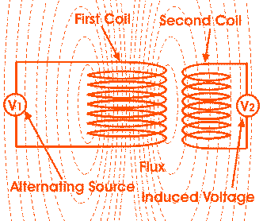

Figure 1: Principle of operation of transformer

A pictorial view of a real three-phase power transformer is shown in Figure 2.

The ratio between the primary and secondary voltages is determined by the turns ratio of the two windings according to the following equation:

$$\frac{V_{P}}{V_{s}}= \frac{N_{p}}{N_{s}}=a$$

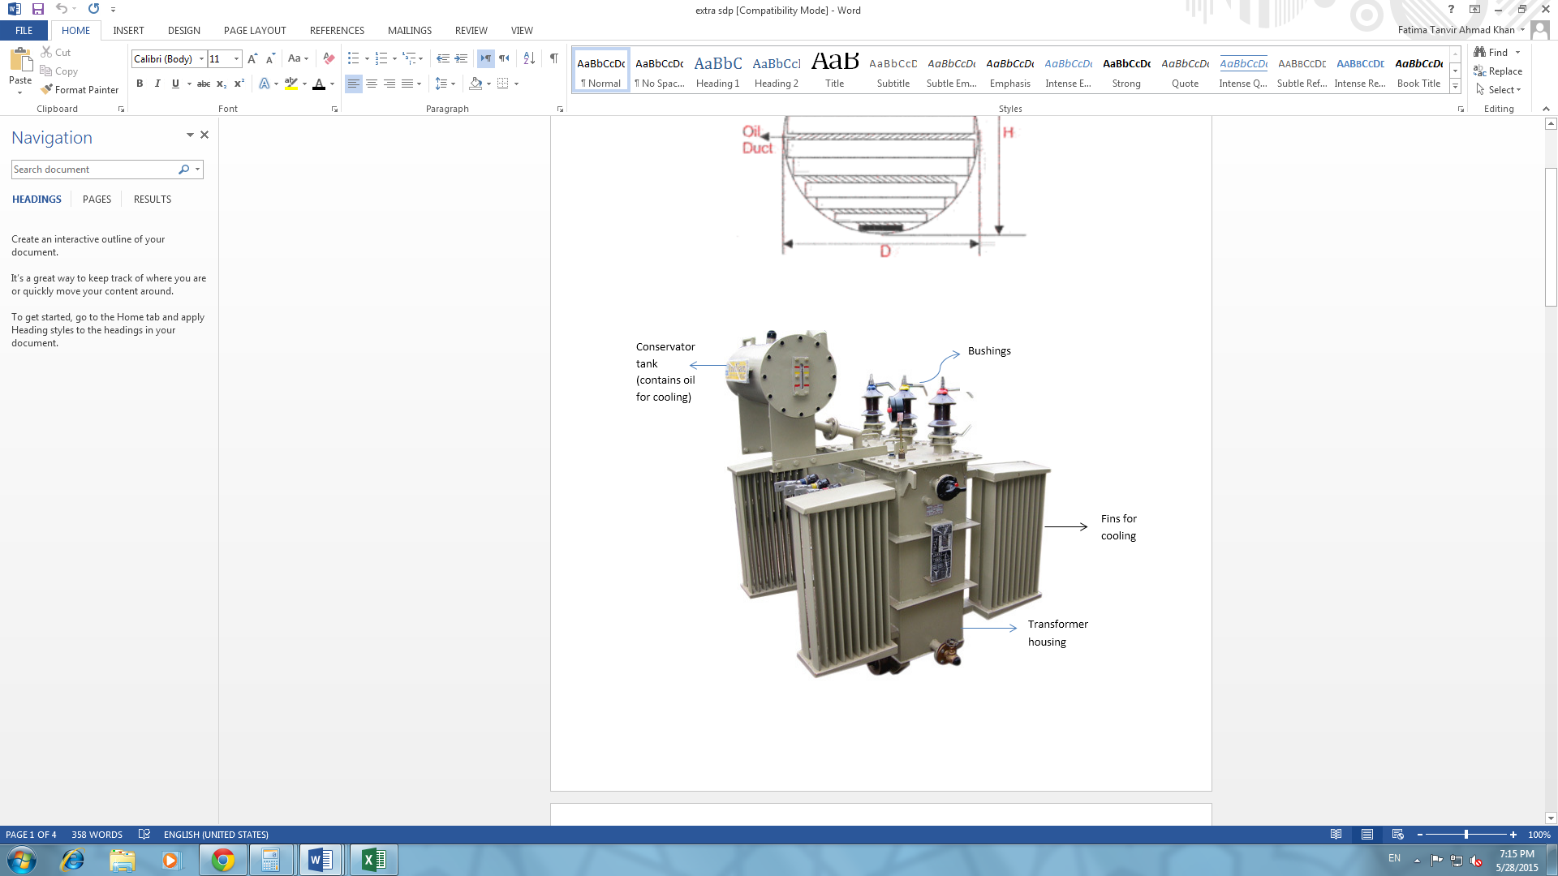

Figure 2: Main parts of a transformer

## 1.3 Classifications of Transformers

Transformers may be classified based on several factors, some of which are listed below:

* **Turns ratio:** If the voltage on the secondary side is higher than that at the primary side, the transformer is known as a step-up transformer (Ns > Np). Contrarily, a step-down transformer (Ns < Np) is one in which the voltage at the secondary side is lower than that at the primary.
* **Construction:** A transformer in which the windings surround the magnetic core is called a core type transformer. On the other hand, if the windings are surrounded by the core, the transformer is known as shell type. The winding is wound on the central limb of the transformer core in shell type of transformers.
* **Power Transformers:** These transformers are used for transmission purposes and are typically rated greater than 33kV.
* **Distribution Transformers:** These are usually rated at less than 33kV and are directly connected to the consumers.
* **Isolation Transformers:** These transformers of 1:1 ratio are used to isolate high voltage circuits from low voltage circuit.
* **Potential Transformers:** Used to measure voltages.
* **Current Transformers:** Used to measure currents.

## 1.4 Three Phase Transformers

Single phase transformers are commonly used in low power electronics or control circuits to isolate one circuit from another. They are also often used to measure voltages or currents, thus called potential or current transformers, respectively.

However, the use of single phase transformers is limited to the above mentioned applications. Most transformers used in power distribution systems and industries are three phase. A three phase transformer can be constructed by simply connecting together three single phase transformers or it may consist of three pairs of single phase windings mounted on a laminated core.

A single three phase transformer requires less material, weighs less and takes up lesser volume than the three single phase transformers used together. This three phase transformer is made up of three sets of primary and secondary windings, each set wound around one leg of an iron core assembly. These sets of primary and secondary windings can be connected in either Delta ( $∆)$ or Wye (Y) configurations.

In **Wye** connection, also known as Star connection connects the 3 polarity ends (or the 3 non polarity ends) together. In **Delta** connection, the polarity end of one winding is connected to the non-polarity end of the next winding. Some merits and demerits of the possible connection schemes have been tabulated below:

### Y- Δ connection

Table 1: Merits and Demerits of Y- Δ connection

|  |  |
| --- | --- |
| **Advantages** | **Disadvantages** |
| Fewer number of turns are required since the primary is star connected; thus making the transformer more economical. | Since the secondary and primary voltages are not in phase with each other, the transformer cannot be paralleled with another transformer. |
| Neutral available on the primary can be earthed to avoid distortion. |  |

### Merits and Demerits of Δ – Y connection

Table 2: Merits and Demerits of Δ-Y connection

|  |  |
| --- | --- |
| **Advantages** | **Disadvantages** |
| Since neutral is available on the secondary side, this type of connection can be used for 3-phase, 4-wire supply system. | Since the secondary and primary voltages are not in phase with each other, the transformer cannot be paralleled with another transformer. |
| Absence of third harmonic components ensures undistorted voltage at the secondary side. |  |

### Merits and Demerits of Δ – Δ connection

Table 3: Merits and Demerits of Δ- Δ connection

|  |  |
| --- | --- |
| **Advantages** | **Disadvantages** |
| Third harmonic component of magnetizing current ensures that the flux, and hence the secondary voltage will be sinusoidal. | Absences of neutral point at the secondary means that the transformer cannot be used for three phase four wire system. |
| In case one transformer of the bank fails, the other two single phase transformers can still support up to 58% of the load. | In case earth fault occurs on one phase, the voltage appearing between windings and the core will be equal to full line voltage. Thus more insulation is required – increasing the cost and size of the transformer. |

### Merits and Demerits of Y – Y connection

Table 4: Merits and Demerits of Y- Y connection

|  |  |
| --- | --- |
| **Advantages** | **Disadvantages** |
| Phase voltage is (1/ $\sqrt{3})$ times the line voltage, thus less number of turns are required in the windings; making the transformer more economical. | Unbalanced phase-to-neutral loads can cause a large voltage drop. |
| Phase current is the same as line current; hence the windings have a high cross section area, and will thus be able to bear heavy loads and short circuit currents. | If the load is unbalanced, the neutral point may shift, leading to an unsatisfactory performance of the transformer. |

### Voltage and Current Relationships

Table 5: Voltage and current relationships for different connections

|  |  |  |
| --- | --- | --- |
| **Connection Type** | **Wye** | **Delta** |
| **Currents** | **Phase current:** IP1 = IL1 , IP2 = IL2, IP3 = IL3  **Line current**: IL = IL1 = IL2 = IL3 | **Phase current:** IP = IL  **Line Current:** IL = IL1 = IL2 = IL3 ­and IP = I12P , I23P = I31P |
| **Voltages** | **Phase voltage:** VP = VL  **Line voltage:** VL = VL12 = VL23 = VL31 | **Phase voltage:** V12 = V12p, V23 = V23p, V31 = V31p  **Line voltage:** VL = V12 = V23 = V31 and  VP = V1P , V2p = V3p |

## 1.5 Multiphase Systems

Multiphase systems (more than 3 phases) have been the main focus of research since their introduction in the late 1960 due to their inherent advantages over their three phase counterparts. They have proved to be advantageous in the field of electric power generation, transmission and utilization.

Multiphase supply is used to drive multiphase motors used in applications that demand high reliability such as electric/hybrid vehicles, electric propulsion systems and aerospace applications. Traditionally, AC-DC-ADC converters were used to supply multiphase motors. However, lately there has been more research to develop static transformation systems that can change the three phase supply to multiphase supply.

## 1.6. Objectives of the Senior Design Project:

The objectives of this project are:

* To design a static transformer which will be connected in a way that allows it to convert the three-phase input supply to five-phase output. This five-phase output is expected to be fixed frequency and fixed voltage.
* Compare the existing solutions of obtaining five-phase supplies and propose a new connection scheme.
* To study the feasibility of the connection using simulation and experimental approach. Moreover, in order to reduce maintenance costs and prevent unscheduled downtimes, condition-based monitoring strategies are used in parallel with conventional planned maintenance. Thus, fault diagnostics for the designed transformer is required to be developed.
* The fault model of the proposed transformer connection will also be developed and analysed and simulation of the faults will be carried out using available software.
* Hardware will be built and the proposed connections scheme will be validated experimentally.
* To write a research paper from the findings of the project.

## 1.7. Problem statement:

In industrial applications, multiphase machines are invariably supplied by AC-DC-AC converters which give multiphase supply from the available three phase grid supply. However, increasing the number of the phases may improve the reliability of the system but it enhances the complexity of the power converter. Recently, direct AC-AC matrix converters have been used due to the various advantages they offer compared to the traditional AC-DC-AC converters. These advantages are their ability to operate at unity power factor for any load and their minimum energy storage requirements. On the other hand, matrix converters have several disadvantages such as the limited voltage transfer ratio and the large number of semiconductors required. In variable speed control of multiphase electric motors, their parameter values are required by the controller e.g. stator resistance, rotor resistance, leakage reactance, magnetizing reactance, iron loss component resistance, stray reactance and inertia. These parameters are obtained by conducting various tests on motors such as no-load test, blocked rotor test and load test etc. Such tests require pure sine wave supply. The power electronic converters mentioned above do not offer pure sine wave. Hence, the best solution is to develop a static transformation to convert the phase number from the three-phase grid supply to $n$-phase (where $n$ > 3). Moreover, the passive transformer designed to obtain the multiphase output is considered more economical and reliable to supply the desired multiphase machine for fixed speed operations. Moreover, the transformer must use a diagnostic scheme and condition monitoring technique in order to observe its health. Hence fault diagnostic model of the transformer is another dimension of work. Hence the problem statements for this project are:

“To design a transformer that converts three-phase supply to multiphase (five-phase) supply in order to obtain pure sine wave”

“To develop mathematical model that represents the fault conditions of the proposed transformer”

## 1.8. Design Constraints

The design constraints of this project span several aspects as discussed below:

**Cost:**

As mentioned earlier, the determination of motor parameters needs a multiphase pure sine wave supply, which cannot be obtained using power electronic converters. The use of static transformer is a unique solution to obtain such a supply, thus the cost is not considered to be an important factor.

**Environmental constraints:**

Since the designed transformer is small and thus dry type, it does not pose any negative effects to the environment. Liquid-cooled transformers often give rise to toxic gases vapours, having an adverse effect on the environment. Moreover, the eventual disposal of the coolant also poses an ecological problem. Furthermore, since our transformer is small, the noise levels will be almost negligible.

**Sustainability:**

Moreover, future work of the project involves fault diagnosis of the transformer. Different types of faults will be analysed mathematically and simulated using softwares. Moreover, the prototype of the transformer will periodically be tested for any unusual behaviour of currents/voltages, which may indicate an incipient fault.

**Manufacturability:**

The prototype of the transformer will be built in the Machines lab at Qatar University. The required components will be ordered to build the transformer as per the theoretical design specifications.

**Health and Safety:**

As mentioned earlier, the dry type transformer does not lead to the emission of any toxic gases. Thus there are no health concerns attached to the project. As for the safety of the user, since the transformer is an electric device, usual precautions need to be taken. For instance, no loose windings should be rattling inside, the temperature of the transformer should not exceed the expected temperature etc. It is preferable that the transformer be plugged into a power strip containing a circuit breaker so it can immediately be switched off in case of any potential problem. Moreover, the transformer should never be used in a place where dampness/water is present.

# **CHAPTER 2: LITERATURE REVIEW**

## 2.1. Transformer Design

Transformer design is a complex process because the designed transformer must meet the desired specifications with the minimum cost possible. (El Hayek, [3]) emphasizes that there are many parameters that must be taken into account in order to design a transformer successfully and efficiently. In addition, some of these parameters might be more significant than others depending on the use of the transformer.

**Basic Transformer Parameters**

### 2.1.1. Types of Transformers

There are many types of transformers with different applications. Thus, transformers can be classified into different categories based on the cooling method, the core or the magnetic circuit construction etc. However, power and voltage ratings are considered a major classification for transformers. Based on these rating, transformers are divided into distribution and power transformers.

A power transformer is responsible for transferring electric energy between the primary circuits and the generator. On the other hand, distribution transformers transfer electric energy from the primary distribution circuit to the secondary circuit which represents the consumer's services circuit.

### 2.1.2. Core

Transformers are usually constructed in either core form or shell form. Core form is when the windings surround the core, while shell form is when windings are surrounded by the core.(Fu,Lee and Wang,[4]) Core form is preferred for high voltage power transformer applications since it is considered more economical. On the other hand, shell form is more prevalent for distribution transformer applications because stacking the core is easier. Moreover, materials used in core construction differ according to the application. Laminated steel cores, solid cores and toroidal cores are some examples of different types of cores. In some transformers where physical core is not necessary, an air core may be used.

##### Square and Stepped Cores

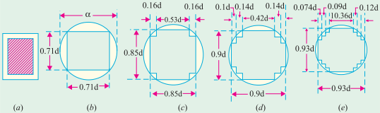

Figure 3: Square and Stepped core laminations

As can be seen from the figure 3 above, various types and sizes of laminations are needed for a stepped core. This would mean performing the design calculations separately for separate laminations, which may be very time consuming and will increase the probability of calculation errors. Moreover, ordering laminations of different sizes may cost more due to the minimum order quantity restrictions of suppliers. As the number of steps increases, more and more space is utilized; thus decreasing the possibility of winding deformation.

Contrarily, a square core uses only one lamination type and size for the entire core. This reduces the number of calculations and hence the probability of calculation errors. Also, only one type and size of lamination needs to be ordered, thus increasing the cost efficiency. However, the main drawback of the square core is that the gaps are considerably large. These gaps need to be filled with an insulating material to prevent the windings from deforming due to any mechanical/thermal stress. However, since the designed transformer is small, the mechanical stress is low. Thus, square core can be used.

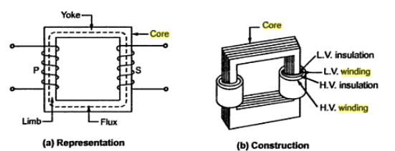 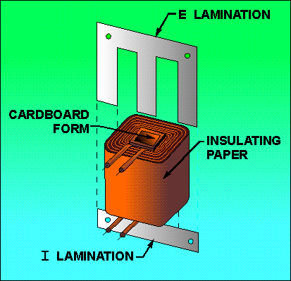

Figure 4: Core Lamination

##### Shell Type/Core Type

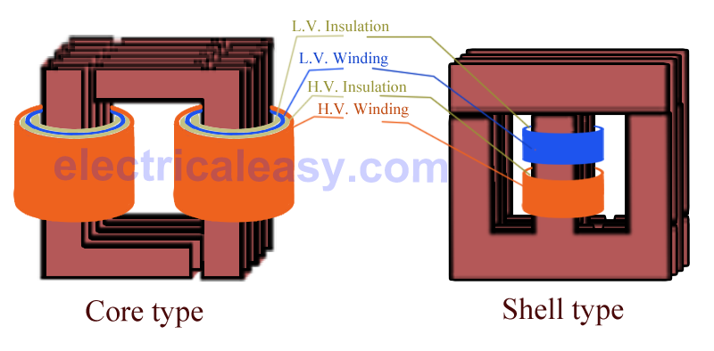

Figure 5: Core and shell Type

In core type transformers, the winding surrounds the core. On the other hand, in shell type transformer, the core surrounds the winding. The table below provides a comparison of the two types:

Table 6: Comparison of shell and core type transformers

|  |  |
| --- | --- |
| **Core Type** | **Shell Type** |
| Relatively lower short-circuit strength. | Sandwich arrangement of coils increases the short-circuit strength of the transformer. |
| Coil sizes changes significantly with an increase in transformer capacity – thus making the transformer more bulky. | Coil size remains the same as transformer capacity increases. |
| The leakage flux may lead to local heating. | The leakage magnetic flux is absorbed by the iron core, preventing local heating. |
| The coils have less mechanical protection when compared to shell type. | The coils are well protected mechanically. |

According to the comparison presented above, shell type transformer will be used in the designed transformer.

### 2.1.3. Frequency and Flux Density

In transformer design, the operating frequency and flux density are considered to be the two most important parameters (Kohan and Abbaszadeh [5]). Increasing the working frequency can decrease the size of the transformer until a certain level is reached where the size cannot be reduced anymore due to the increase in temperature rise and losses which may affect the transformer negatively. This frequency level is called the design frequency.

### 2.1.4. Cooling system

The cooling system is an important parameter in the process of designing a transformer because controlling the temperature of the transformer within suitable limits will help increase the life span of the transformer. Therefore, a cooling system or method is essential to accelerate heat dissipation from the transformer. Various cooling methods have been developed and used over the years. The choice of cooling method depends on the environment and the application where the transformer is used.

In addition, transformers can be designed either as dry-type or liquid immersed type with accordance to the cooling method. Liquid immersed employs mineral oil or synthetic liquid as an insulating medium, while dry-type is where the transformer is allowed to cool down through natural air circulation.

### 2.1.5. Transformer Standards

Transformer standards are issued by three main institutions; ANSI/IEEE, IEC, and CENELEC. First, IEEE stands for The Institute of Electrical and Electronics Engineers. These standards are considered national standards issued by IEEE societies in USA.

IEC stands for International Electro-technical Commission, which was founded in London during 1906. Moreover, IEC standards does not include a description of transformer design and production, instead they define a set of tests the transformer should be subjected to in the final stages of production and they also include acceptance criteria to determine whether the transformer have long life and high reliability or not.

CENELEC stands for Comité Européen de Normalisation Electro-technique which is also known as European Committee for Electro-technical Standardization. It was founded in 1973 and these standards (EN standards) are international standards issued and approved by working groups through voting among countries forming the European Union (EU).

It is important to note that the use of these different standards is a voluntary matter unless it was specified by a contractual relationship.

Figure 6: Percentage participation of IEEE, IEC and CENELEC standards

IEEE standards for transformer design have been chosen to be followed in this senior design project as they're known and followed internationally. IEEE transformer committee working groups are assigned for continuous important of liquid immersed distribution, power and regulating transformer standard.

## 2.2 Fault Diagnosis of a Transformer

Fault diagnosis of transformers is crucial in order to ensure stable operation of industries and electrical power supply to consumers. Due to the constant influence of electrical, mechanical, thermal and environmental stresses, transformer faults are inevitable. Faults encountered in a transformer can be broadly classified into:

**External faults or through faults:** These are conditions that stress the transformer beyond capacity, eventually leading to internal faults. This includes overloading, overvoltage and power swings.

**Internal faults:** These faults occur within the transformer’s protection zone and can be further classified into:

(i) Internal short circuit faults: Faults in tap changer equipment or bushing flash over may lead to internal SC faults that occur on the windings of the transformer and are either turn to turn, turn to earth or inter-turn. SC faults produce over currents which may cause winding movements, shorted turns, and extreme mechanical stress of core and coil assembly. Fast action is required by the protective devices to isolate the transformer and avoid any major breakdown in the system. This type of fault is indicated by any unbalance in voltage or current at the winding terminals.

(ii) Incipient faults: These faults do not usually pose any immediate hazard, but may slowly develop into major faults. Incipient faults mainly result from poor electrical connection, core faults, regulator faults, failure of the coolant and bad load sharing between transformers. These faults may convey asymmetric, non-periodic and sporadic arcing currents of random magnitude. However, they do not cause any unbalance in voltage or current at the winding terminals and hence cannot be detected by protective equipment meant to operate under SC faults (Bhalla, Bansal, and Gupta, [6]).

### 2.2.1. Fault Diagnosis:

Any fault occurring in a transformer can lead to a catastrophic failure and costly outages. A study of the history of modern transformer breakdowns shows that 70% - 80% of transformer failures are eventually traced to internal windings faults. These faults usually result from the degradation of the insulation system due to thermal, mechanical or electrical stresses. Reducing insulation quality will eventually cause a breakdown in the insulation causing adjacent windings to be shorted with each other or a winding being shorted to the earth. Over the years, several diagnostic methods have been developed to detect these internal faults of a transformer. Some of these methods are discussed below:

### 2.2.2. Dissolved Gas Analysis (DGA):

In oil immersed transformers, the detection of certain gases can be a clear indication of a malfunction. These gases are formed due to thermal or electrical disturbances and can be found dissolved in the oil, or in a gas blanket above the oil or in special gas collecting devices. This method of diagnosing transformer faults has been developed from Buchholz relay application. DGA works by determining the ratios of five main gases dissolved in the oil; these ratios can then be analyzed to evaluate possible faults.

### 2.2.3. Buchholz Relay Safety Device:

The Buccholz Relay is a protective device mounted on the pipe connecting the transformer tank to the conservator. When a minor fault occurs in the transformer, the insulating oil is decomposed into CO2, CO and various hydrocarbon gases. These gases accumulate in the upper part of the relay chamber, decreasing the level of oil in the container and hence lowering the float. When the float reaches a specific level, it causes an alarm circuit to be energized.

In the case of a major fault, a large quantity of gas may be produced. This will lead to an abrupt rise in pressure within the tank and will cause oil to flow into the conservator. This oil flow causes the float to be lowered, tripping the circuit breaker or energizing the alarm circuit.

# **CHAPTER 3: TRANSFORMER DESIGN**

**3.1 Introduction**

The notion of multiphase passive transformation system dates back to the early fifties of 20th century. At that time, the general theory of phase transformation to convert n to m phases on a k-limbed transformer was introduced (Parton, [8]). This idea has been used to develop transformers that will produce five phase (Iqbal, Moinuddin, Khan, Ahmed, and Abu-Rub, [9]) or seven-phase (Moinuddin, Iqbal, Abu-Rub, Khan and Ahmed, [10]) outputs when fed from a three phase supply.

To obtain a five phase output from the transformer, the general idea is to have three separate cores, each consisting of one primary coil and more than one secondary coils. The secondary coils will have different number of turns and will be connected in specific ways so as to produce the desired phase shift of 72 degrees. Some alternate solutions have been discussed below:

## 3.2. Alternative Solutions

Three alternative designs were considered for the design of the transformer. Following are some brief details and analysis of these designs.

### 3.2.1. Solution # 1:

The connection scheme proposed in [9] is based on the assumption that the three phase input supply is perfectly balanced, i.e. the summation of the three phase voltages adds up to zero. This assumption makes it possible to obtain five phase supply by using only 8 secondary coils, thus reducing the total number of turns and consequently the size of the transformer as compared to the other two proposed solutions. However, in this case, pentagon connection at the secondary side is not possible. In fact, the secondary can only be connected in star, thus limiting the use of the transformer. Moreover, the three phase currents in this connection scheme show a zero sequence component equal to 5.6% of the rated current. This requires the connection of a star point in the primary winding to allow for neutral current flow. Furthermore, an unbalance of the input three phase supply will cause an unbalance in the desired five phase output voltages. The winding connection for this design is shown in Appendix B

### 3.2.2. Solution # 2:

Another possible solution could be the transformer connection presented in (Abdel-Khalik, Shafik, Elserougi, Ahmed and Massoud, [11]). The idea presented in [8] uses the Scott connection to transform three-phase to power to two-phase output using two single phase transformers. This two phase supply can then be transformed to any n-phase output. The transformer proposed in [11] makes use of two magnetic cores with two primary coils and 2n-1 secondary coils where n represents the number of output phases. Thus, nine secondary coils will be required to obtain a five phase output.

Since only two cores are used, this connection scheme greatly minimizes the core volume. However, it uses a larger number of turns, thus increasing the resistance and consequently the copper losses. It also exhibits a high magnetizing reactance, which would lead to greater iron losses, having an adverse effect on the efficiency of the designed transformer. In this design, efficiency is one of the parameters to be optimized, thus this connection scheme may not be the best solution. The winding connection for this design is shown in Appendix B.

### 3.2.3. Solution # 3:

Similar to the general idea, three separate cores with a primary and a number of secondaries is proposed to achieve the desired five phase output. However, each core will consist of three secondaries, thus leading to a total of 9 secondary coils, as opposed to 8 in the first solution. This is the main contribution of the project, i.e. proposal for a new connection scheme of a transformer to obtain five phases from three phase input. This will allow the secondary side to be connected in both, star and pentagon forms. Moreover, all secondary coils will have the same cross sectional area unlike the first solution, in which one secondary coil would have a larger cross sectional area to handle the currents of two phases. In high rating transformers, this can cause an uneven distribution of losses, leading to different thermal loading and hence complex cooling systems. The number of turns needed in the secondary coils will be less than what would be required if the second solution was to be implemented. This will reduce the cost and increase the efficiency of the transformer.

The table below shows a quick comparison of the three solutions:

Table 7: Comparison of the three solutions for 2kVA, 440/440V transformer

|  |  |  |  |
| --- | --- | --- | --- |
| **Parameter** | **Solution # 1** | **Solution # 2** | **Solution # 3** |
| **Total Primary Turns** | 771 | 834 | 771 |
| **Total Secondary Turns** | 1292 | 1629 | 1415 |
| **Total Turns** | 2063 (100%) | 2463 (119%) | 2186(106%) |
| **Primary Resistance (Ω)** | 0.048 | 0.052 | 0.048 |
| **Secondary Resistance (Ω)** | 0.08 | 0.101 | 0.088 |
| **Space needed by primary (mm2)** | 1609 | 1740 | 1609 |
| **Space needed by secondary (mm2)** | 2696 | 3400 | 2953 |
| **Total space needed (mm2)** | 4305 | 5140 | 4562 |

As table 7 shows, solution 2 uses a considerably higher number of turns than the other two solutions. This increases the cost of the transformer and also leads to greater copper losses. Also, it requires more space than the other two solutions. In this project, since cost and efficiency are the main factors to be optimized, solution 2 is not feasible.

As for solution 1, it uses the lowest number of turns, which would translate into lower cost and better efficiency. However, as mentioned earlier, the secondary of solution 1 can only be connected in Star; thus making the transformer unsuitable for pentagon loads. Moreover, since the secondary windings are not symmetrical, they will not carry the same current. Thus the thickness of the wires to be used will be different which will lead to unequal losses, and therefore unequal heating.

Solution 3 proves to be the optimum solution for us, allowing us to use a lower number of turns, thus fulfilling the cost and efficiency constraints of this design. It will also allow us to connect pentagon loads. Moreover, symmetrical secondaries will ensure the same cross sectional areas of all secondary coils, thus leading to even losses.

## 3.3. Proposed Transformer Design (Solution #3)

For this project, a Y-Y connected three phase to five phase transformer with an output rating of 2kVA, 440V/440V is to be designed. Important design steps and calculations are explained below.

Since the third solution is chose, the transformer will consists of three separate cores. Each core consists of one primary and three secondary coils, thus leading to a total of 9 secondary coils. These coils will be connected in a specific manner so as to produce five outputs phase shifted by 72 $°$. The connection diagram of the windings and the corresponding phasor diagrams are shown below:

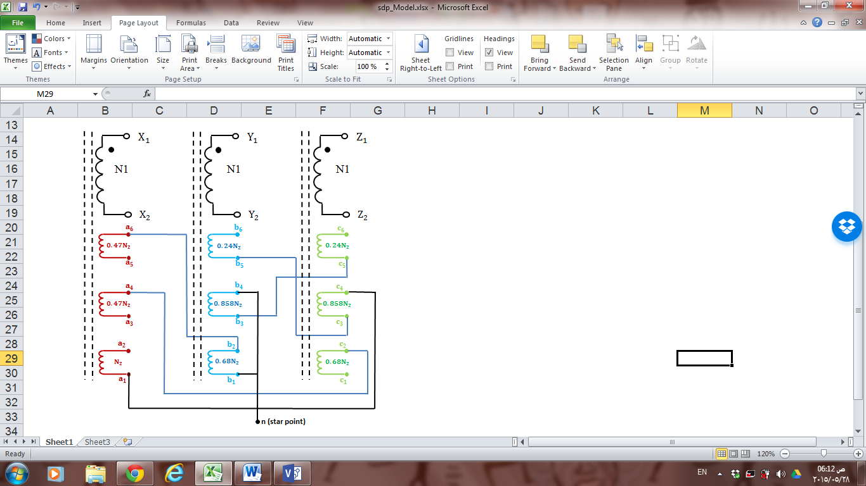

Figure 7: Winding arrangement and connections of the designed transformer

Vector calculations and trigonometric properties were used to obtain the ratios of the secondary windings that would allow us to obtain five outputs of the same magnitude but phase shifted by 72 $°.$ An example of this analysis for output phase ‘b’ is shown in Figure 8, and the complete phasor diagram is shown in Figure 9. Analyses of the other output phases are shown in Appendix A.

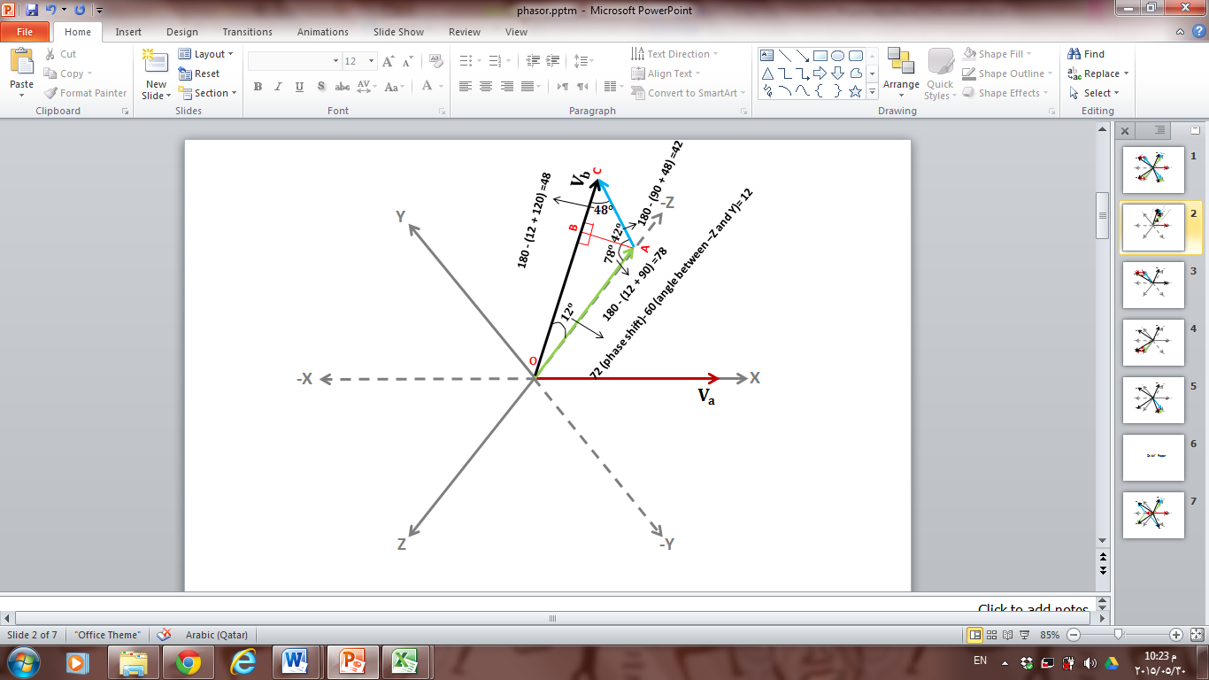

Figure 8: Mathematical Analysis for phase ‘b’

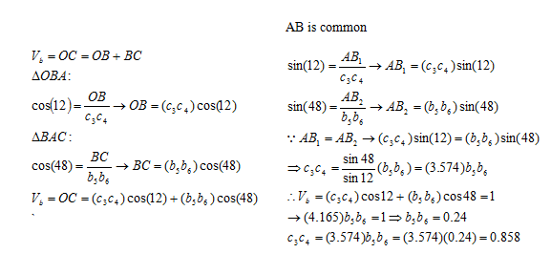

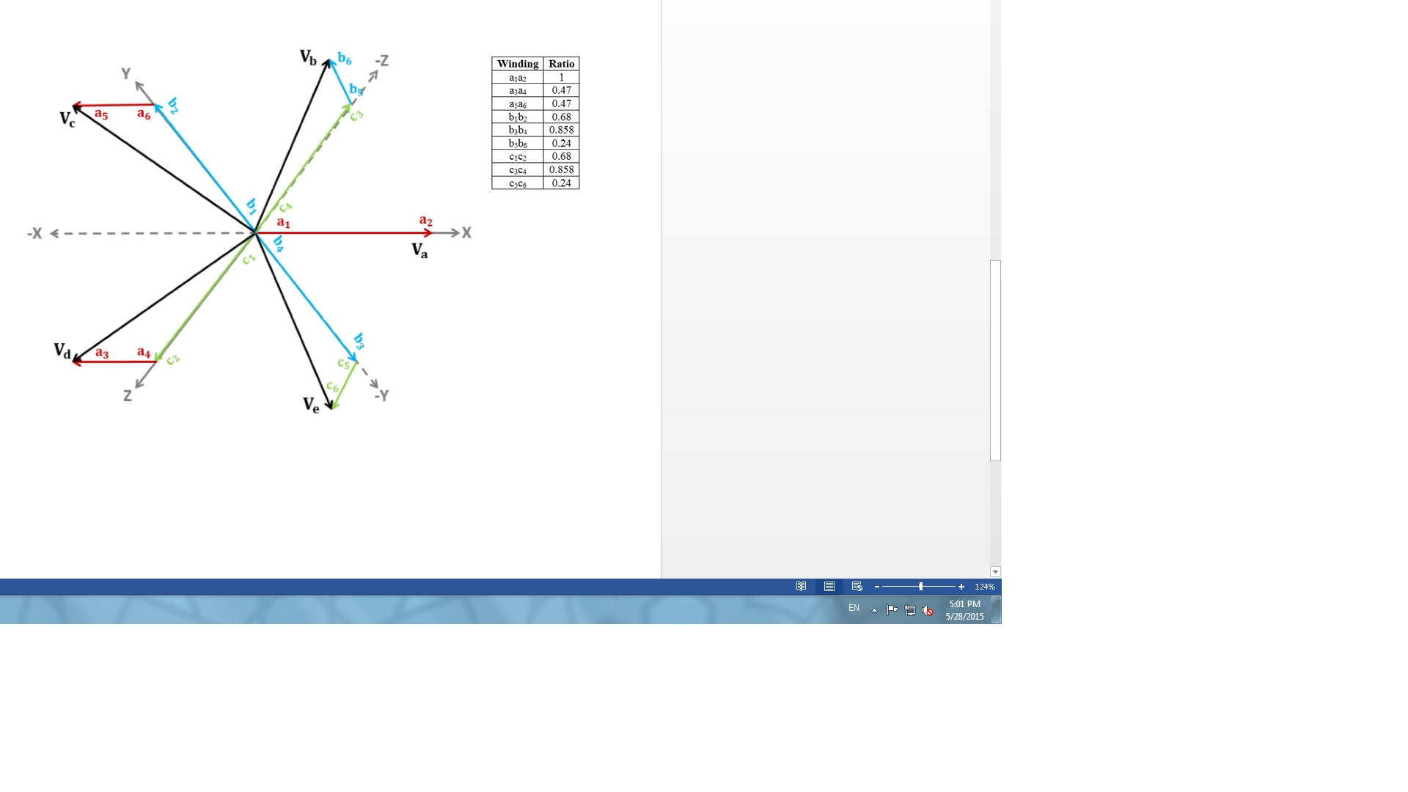

Figure 9: Phasor Diagram of the designed transformer

. Since the input consists of three phases, Vx, Vy and Vz will be phase shifted by 120 $°$ ($\frac{360}{3}$ =120 $°$). Thus, taking Vx as the reference, the input phases can be expressed by:

|  |  |  |
| --- | --- | --- |
|  |  | (1) |
|  |  | (2) |
|  |  | (3) |

Similarly, the consecutive phases of the five-phase output will have a phase shift of 72 $°$ ($\frac{360}{5}$ =72 $°$). Thus, the outputs can be expressed as:

|  |  |  |
| --- | --- | --- |
|  |  | (4) |
|  |  | (5) |
|  |  | (6) |
|  |  | (7) |
|  |  | (8) |

Moreover, the following equations can be deduced from the phasor diagram and the ratios obtained:

|  |  |
| --- | --- |
|  | (9) |
|  | (10) |
|  | (11) |
|  | (12) |
|  | (13) |

Equations (9) to (13) can be rewritten in terms of sine, as shown in the matrix below:



### 3.3.1. Step 1: Core Design

|  |  |  |
| --- | --- | --- |
|  |  | (14) |

Where the value of ‘K’ depends on the type of transformer and what quantity is being optimized. In this case, since the quantities to be optimized are cost and to some extent efficiency, ‘K’ was assumed to be 0.7.

|  |  |
| --- | --- |
|  |  |

Then, using the general emf equation,

|  |  |  |
| --- | --- | --- |
|  |  | (15) |

$$φ_{m}= \frac{0.9899}{4.44*50}=4.46mWb$$

Now the net iron area can be calculated using

|  |  |  |
| --- | --- | --- |
|  |  | (16) |

Where Bm represents the maximum flux density in the core. For this design, a low value of Bm is assumed to reduce core losses and hence increase the efficiency of the designed transformer.

${Assuming B}_{m}=1.25Wb/m^{2} ; A_{i}= \frac{φ_{m}}{B_{m}}=3567.21{mm}^{2}$

The core of a transformer is often laminated to reduce the eddy currents and hence the core losses. These laminations will lead to an increase in the core area. Thus, assuming a stacking factor of 0.9, the gross iron area can be calculated as

|  |  |  |
| --- | --- | --- |
|  |  | (17) |



### 3.3.2. Step 2: Design of Primary Winding

The number of turns in the primary winding will be calculated as shown below. Since the primary winding is connected in Wye, the voltage per phase is 1/ $\sqrt{3}$ times the line voltage.

 (18)



Since number of turns can only be an integer (257 in this case), then the volts per turn will change to

 (19)



 (20)

Assuming 90% efficiency of the transformer,



Assuming primary current density Jp = 4A/mm2,

|  |  |  |
| --- | --- | --- |
|  |  | (21) |



Area of the conductor is given

 (22)

From (22), the diameter of the conductor can be calculated as:

$$So d= \sqrt{\frac{1.26*4}{π}}=1.27mm$$

The closest diameter from standard SWG/AWG tables can now be chosen.

### 3.3.3. Step 3: Design of Secondary Windings

The secondary current is determined using

 (23)



Assuming secondary current density = Js = Jp = 4A/mm2, the diameter of secondary conductor can be calculated using (21)



Using (22), the diameter of the secondary conductor can be calculated as

$$d= \sqrt{\frac{1.1375*4}{π}}=1.203mm$$

From the standard SWG/AWG table, the closest diameter is 1.25mm. After medium insulation, the diameter of the insulated conductor = 1.35mm.

The ratios obtained earlier from the phasor diagram were used to calculate the number of turns of the secondary windings, as shown below:

Table 8: Number of secondary windings

|  |  |  |
| --- | --- | --- |
| **Primary** | **Secondary Winding** | **Number of turns in secondary winding (rounded figure)** |
| **Phase X** | a1a2 | 1*257 = 257 |
|  | a3a4 | 0.47*257 = 121 |
|  | a5a6 | 0.47*257 = 121 |
| **Phase Y** | b1b2 | 0.68*257 = 175 |
|  | b3b4 | 0.858*257 = 221 |
|  | b5b6 | 0.24*257 = 62 |
| **Phase Z** | c1c2 | 0.68*257 = 175 |
|  | c3c4 | 0.858*257 = 221 |
|  | c5c6 | 0.24*257 = 62 |

### 3.3.4. Step 4: Window Dimensions

The window of a transformer is used to place the primary and secondary windings, along with the insulation and the bobbin on which the windings are to be placed. The window space required by a winding can be calculated using:

|  |  |  |
| --- | --- | --- |
| Space required by each winding | = | (24) |
|  | S.F. = | (25) |

For both, primary and secondary windings, the diameters of bare and insulated conductors are 1.25 and 1.35mm respectively. So the space factor for each primary and secondary winding will be

${0.8*(\frac{1.25}{1.35})}^{2}$ = 0.686,

Therefore, using (24), the space needed for each primary winding can be determined as

$\frac{257*[\frac{π}{4}{\left(1.35\right)}^{2}]}{0.686}={536.25mm}^{2}$

Similarly, the space needed by each secondary winding was calculated using (24) and (25), based on the turn ratios obtained earlier. Results of the calculations are shown in the table below:

Table 9: Space needed by the secondary windings

|  |  |  |
| --- | --- | --- |
| **Primary** | **Secondary Winding** | **Space needed by the secondary winding (mm2)** |
| **Phase X** | a1a2 | 536.25 |
| a3a4 | 252.48 |
| a5a6 | 252.48 |
| **Phase Y** | b1b2 | 365.16 |
| b3b4 | 461.14 |
| b5b6 | 129.37 |
| **Phase Z** | c1c2 | 365.16 |
| c3c4 | 461.14 |
| c5c6 | 129.37 |

A 20% increase in required window space can be approximated due to the insulations. So window space needed by each transformer will be:

**1st T/F**: 1.2 *[536.25 + (536.25 +252.48+252.48)] $≅{1893mm}^{2}$

**2nd T/F**: 1.2 *[536.25 + (365.16+461.14+129.37)] $≅$ ${1790mm}^{2}$

**3rd T/F**: 1.2 *[536.25 + (365.16+461.14+129.37)] $≅$ ${1790mm}^{2}$

### 3.3.5. Step 5: Selection of appropriate stampings

Now stampings are to be selected that will give us the required window area and width of central limb. Choosing a square section for the central limb, required width of central limb will be

$\sqrt{A_{gi}}= \sqrt{3963.57}=62.96mm≅63mm$

The lamination shown below was chosen. It provides a window of height 7.5” (190.5mm) and width 2” (50.8mm). Area of window provided = 190.5*50.8 = **9677.4mm2**. Therefore this EI lamination can be used for all 3 transformers as it provides the needed central limb with and an area greater than what is required.

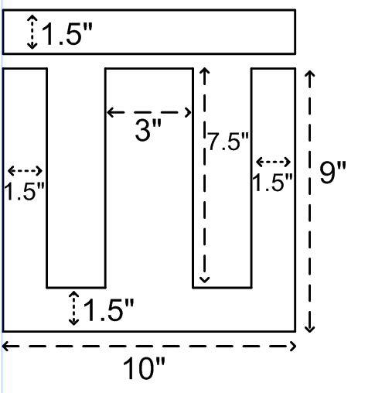

Figure 10: The EI Lamination to be used

### 3.3.6. Step 6: Performance Calculations

Based on the calculations above, the losses and efficiency of the transformer can be estimated. To calculate the losses of the transformers, the resistances of the windings should be determined. Resistance can be calculated using the formula:

|  |  |  |
| --- | --- | --- |
|  |  | (26) |
|  |  | (27) |

According to the IEEE C57.134-2000 standards, losses of a transformer are typically calculated at 75 $℃.$ At this temperature, the resistivity of Copper is 0.021 $μΩ*m$. Since diameter of primary and secondary conductors are equal, their length of mean turns will also be equal, l = π * 1.35 = 4.24mm

Converting all quantities to SI units, the resistances were calculated as shown below:

Thus **resistance of each primary winding** will be

$257*\frac{{(0.021*10}^{-6})*({4.24*10}^{-3})}{\left(π/4\right){(1.35*{10}^{-3})}^{2}}$ = 0.016Ω

### 3.3.7. Step 7: Resistances of secondary windings:

a1a2: 257 $* \frac{{(0.021*10}^{-6})*({4.24*10}^{-3})}{\left(π/4\right){(1.35*{10}^{-3})}^{2}}$ = 0.016Ω

Similarly, the resistance for each secondary winding was calculated according to the number of turns. Values obtained are shown in Table 10.

### 3.3.8. Step 8: Total Copper loss of each transformer:

Table 10: Copper loss of each transformer

|  |  |  |  |  |  |
| --- | --- | --- | --- | --- | --- |
| **T/F no.** | **Primary Resistance (**Ω) | **Secondary resistance (**Ω) | **I2R loss primary (W)** | **I2R loss secondary (W)** | **Total Copper loss (W)** |
| 1 | 0.016 | 0.016+7.53m+7.53m = 0.031 | (5.05)2*(0.016) = 0.408 | (4.55)2*(0.031) = 0.642 | 0.408+0.642=1.05 |
| 2 | 0.016 | 0.011+0.0137+3.86m = 0.0286 | (5.05)2*(0.016) = 0.408 | (4.55)2*(0.0286) = 0.592 | 0.408+0.592 =1 |
| 3 | 0.016 | 0.011+0.0137+3.86m = 0.0286 | (5.05)2*(0.016) = 0.408 | (4.55)2*(0.0286) = 0.592 | 0.408+0.592=1 |

### 3.3.9. Step 9: Core Losses

According to IEEE Std C57.12.90-1999, the approximate core loss will be 1W/kg for the assumed flux density (1.25W/m2)

 (28)

(29)

where the length of flux path is the sum of the height and width of the window. In this case, since height of window = 190.5mm and width of window = 50.8mm. Therefore length of flux path = 190.5+50.8 = 241.3mm = 0.2413m

Therefore, mass of iron in each core = $7870*\left({3567.21*10}^{-6}*0.2413\right)=6.77kg$

Thus iron loss of each transformer will be (6.77kg)*(1W/kg) **= 6.77W**

### 3.3.10. Step 10: Total loss of each transformer:

Table 11: Total loss of each transformer

|  |  |  |
| --- | --- | --- |
| T/F | Total loss(W) | Efficiency = $\frac{P_{out}}{P_{out }+P_{losses}}*100\%$ |
| 1 | 1.05+6.77 = 7.82 | 99.611% |
| 2 | 1 + 6.77 = 7.77 | 99.613% |
| 3 | 1 + 6.77 = 7.77 | 99.613% |

## 3.4. Simulation of the Designed Transformer

### 3.4.1. Simulink

The designed transformer was simulated using Simulink to see if the desired five phase output is obtained. Simulations of the proposed design and alternative designs are shown in Appendix B.

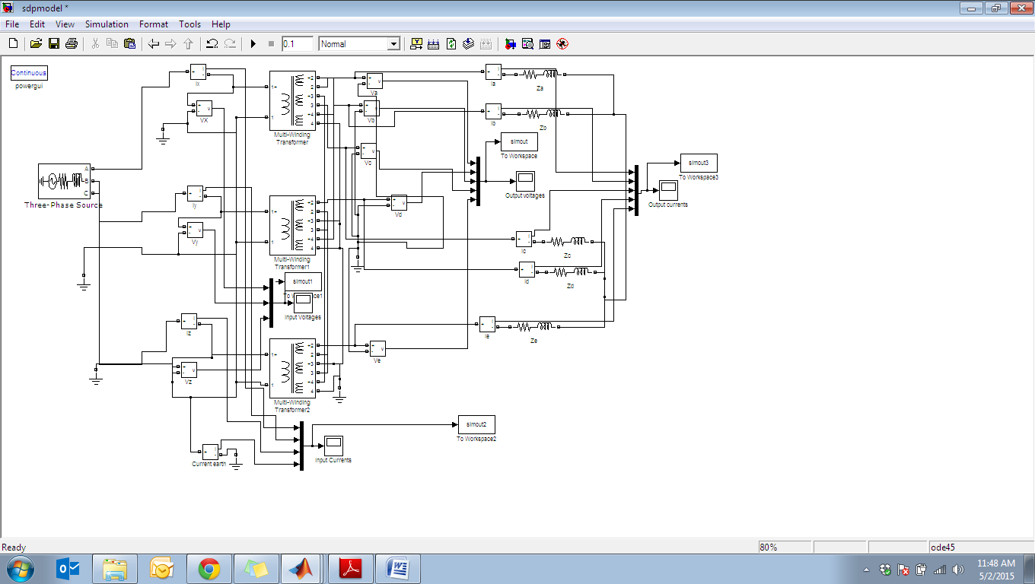

Figure 11: Simulink block diagram used to simulate the designed transformer

**3.4.2. Finite Element Method Magnetics (FEMM)**

The Finite Element Method Magnetics (FEMM) is an open source finite element analysis software package for solving electromagnetic problems. It addresses 2-dimensional planar and 3-dimensional axisymmetric linear and nonlinear harmonic magnetic and magneto static problems and linear electrostatic problems.

In the project, FEMM was used to model the transformer and see its behaviour. FEMM utilizes finite element analysis for the solution of problems. The problem is analyzed using two different stages:

1) ***pre-processor:*** In this stage the problem geometry must be drawn, and the materials and boundary conditions must be defined.

2) ***post processor stage***: This stage is to view solutions and **has three modes:  
 a)** in point values mode you can click on various points in the solution region;   
 **b)** in contour mode you can define arbitrary contours in the solution region  
 **c**) in block mode you can define a sub domain in the solution region

Using the dimensions of the EI lamination from Figure 8, the coordinates were calculated and set in FEMM to draw the EI lamination shown below.

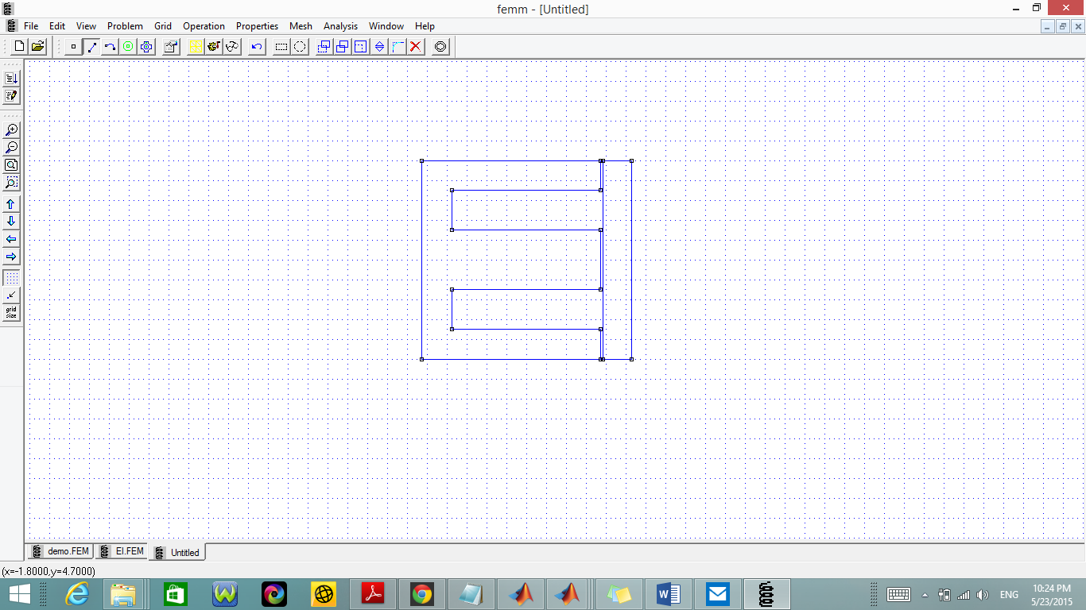

Figure 12: Representation of EI lamination in FEMM

The primary winding will be done in the central limb while taking care not to exceed the window size. According to the calculations done in Chapter 3, the primary coil was chosen to be SWG 14, providing a diameter of 0.08 inches circular wire.

The total number of primary turns for each single phase transformer (257) will be divided into 8 layers; 4 to fill the height of the central limb and 4 to fill its width.  
257/4=64.5 will be 65 turns (65*0.08) = 5.2 inches, and the insulation is assumed to be 0.27”. Thus the entire length and width of winding will be 5.47”. The same procedure will be followed for secondary windings. The figure below shows how the windings were wrapped around the central limb. Each winding has its own characteristics such as the current, number of turns and material wire etc. In the figure above, the negative sign in -121 and -257 indicates the induced voltage and shows opposite direction of current flowing to complete the loop from positive to negative.

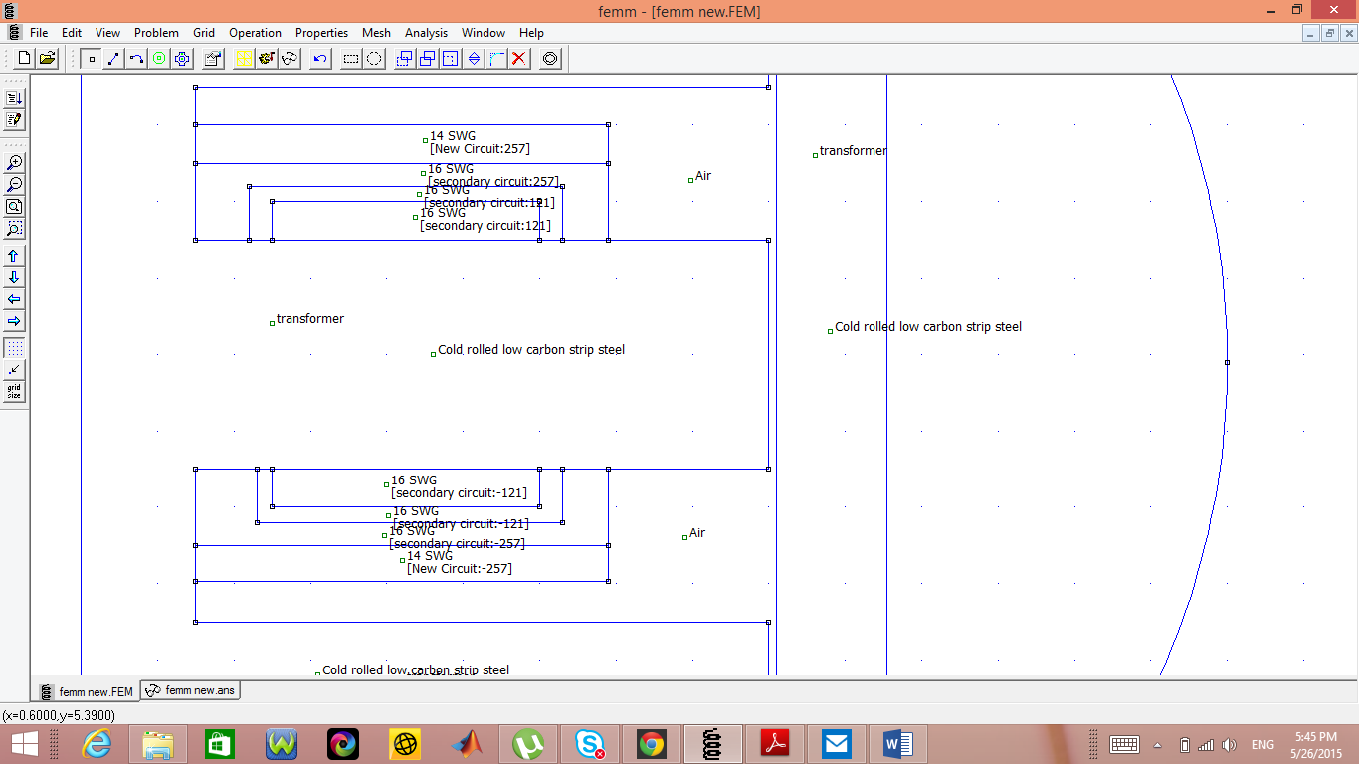

Figure 13: Transformer in FEMM with windings on the central limb

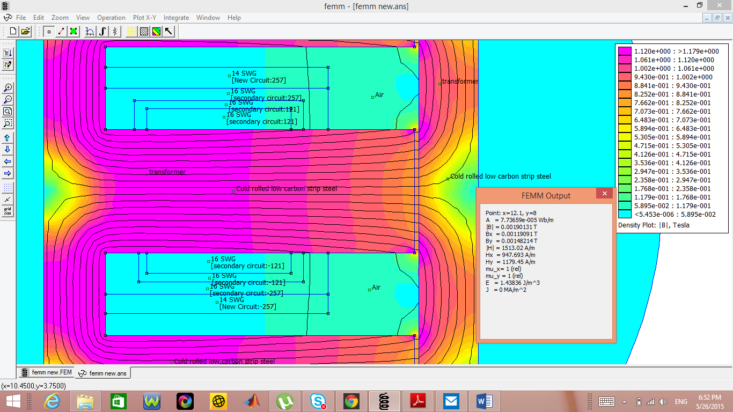

Figure 14: Results obtained using FEMM Analysis

For each colored part in the figure 16 above, the related data (flux density, current density, etc.) is shown in the small window on the right. The color code represents the variations in flux density.

## 3.5. Graphical User Interface for Design of Multiphase Transformer

A Graphical User Interface (GUI) was built using Excel. This allows the calculations of three-phase to five-phase transformer to be automated. The user is required to enter basic information about the transformer, such as the kVA rating, voltage rating, etc. The Excel will then calculate all other parameters needed for the design.

This allows the user to avoid any tedious calculations, thus saving time and avoiding any calculations mistakes. Also, the user can easily change certain transformer data in the file to see how the other parameters would be affected.

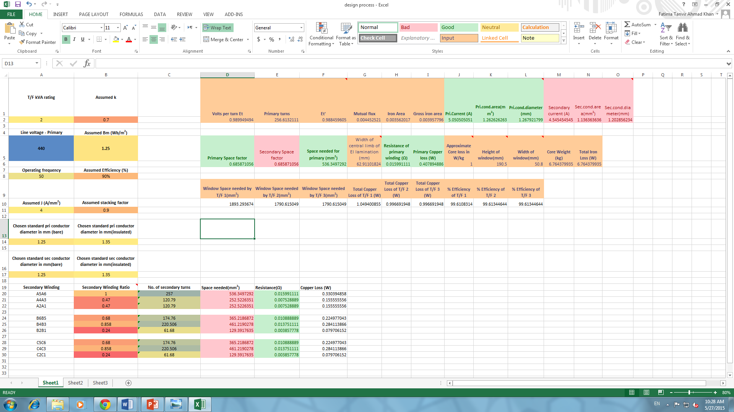

Figure 15: Transformer data to be entered by the user



Figure 16: Secondary winding ratios to be entered by the user and the resulting computation

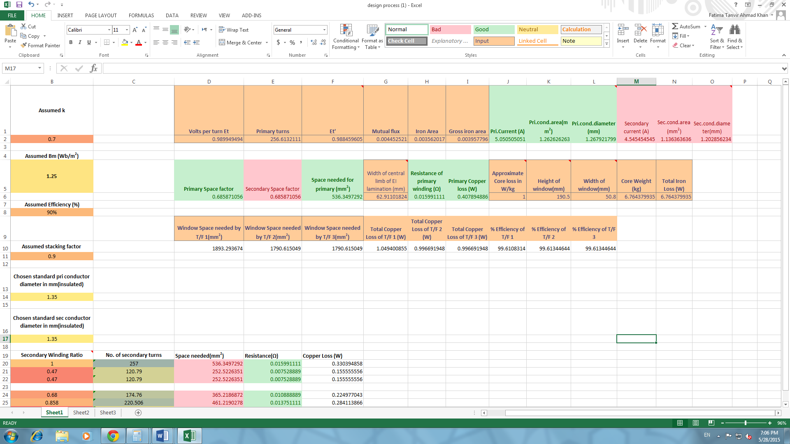

Figure 17: Parameters calculated by the software

# **CHAPTER 4: FAULT DIAGNOSIS OF THE DESIGNED TRANSFORMER**

## 4.1 Introduction

Transformers are considered to be one of the most important equipment in a power system. Due to the constant electrical, mechanical and thermal stresses, transformer faults are unavoidable. Timely fault detection is vital in order to avoid transformer failures and their catastrophic effects on power systems and/or industrial operations.

Fault diagnosis also helps maximize the lifetime and efficiency of a transformer. Several techniques have been developed to detect the possibility of internal faults of a transformer. Such faults can be modelled using fault diagnosis software such as EMTP (ElectroMagnetic Transients Program), ATP (Alternative Transients Program). These programs can be used to simulate faults between any two turns or between any turn and the earth of the transformer windings.

## 4.2. Mathematical Model of a Transformer

Any transformer can be modelled by [R] and [L] matrices. These are square matrices of order equivalent to the total number of windings of the transformer. If data from excitation and short circuit tests is available, the values of these matrices can be calculated using the BCTRAN routine of the EMTP software (Bastard, Bertrand, Meunier [12]). If this data is not available, the values of these matrices can be computed using the equations given below:

|  |  |  |
| --- | --- | --- |
|  |  | (30)  (31)   (32) |

Where k represents the coupling the coefficient. The coupling coefficient measures the portion of the total flux lines that cut both, the primary and the secondary windings. In this case, ‘k’ was assumed to be 0.85.

As shown in Figure 20, the designed transformer consists of 12 windings (each single phase transformer is made up of one primary and three secondary windings). Thus the R and L matrices will be of order 12 as shown below:

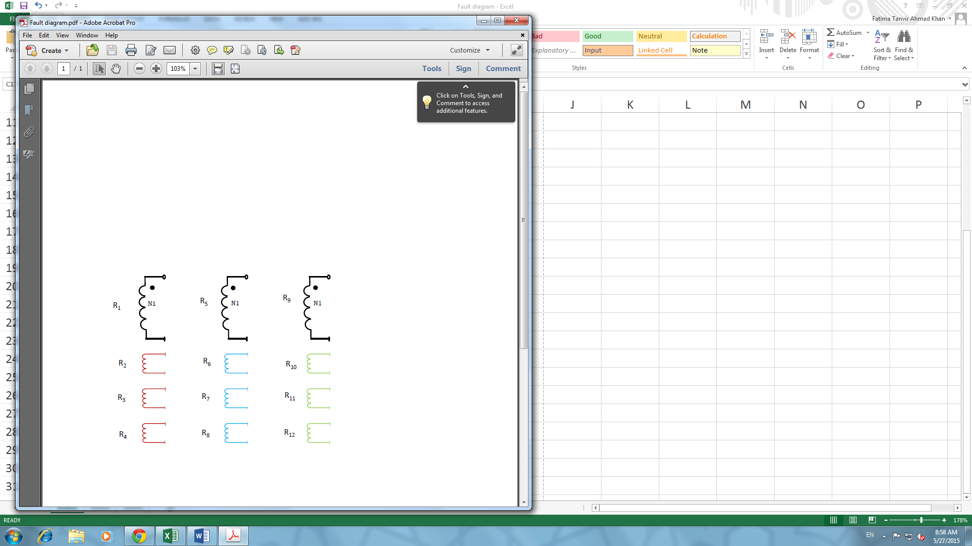

Figure 18: Winding representation of the designed transformer

As shown in the matrices below, the diagonals of the R matrix represent the resistance of the windings (R11 shows the resistance of winding 1, R22 shows the resistance of winding 2 and so on). As for the L matrix, the diagonals represent the self-inductances of the windings and other matrix entries represent the mutual inductance between coil ‘i’ and ‘j’. For example (L11 represents the self-inductance of coil 1, L1-2 represents the mutual inductance between coils 1 and 2 and so on).

R = 

L= 

Using equations 30–32, the R and L matrices were calculated as shown below:

R= $\left[\begin{matrix}0.016 & 0 & 0 & 0 & 0 & 0 & 0 & 0 & 0 & 0 & 0 & 0 \\ 0 & 0.016 & 0 & 0 & 0 & 0 & 0 & 0 & 0 & 0 & 0 & 0 \\ 0 & 0 & 0.00753 & 0 & 0 & 0 & 0 & 0 & 0 & 0 & 0 & 0 \\ 0 & 0 & 0 & 0.00753 & 0 & 0 & 0 & 0 & 0 & 0 & 0 & 0 \\ 0 & 0 & 0 & 0 & 0.016 & 0 & 0 & 0 & 0 & 0 & 0 & 0 \\ 0 & 0 & 0 & 0 & 0 & 0.011 & 0 & 0 & 0 & 0 & 0 & 0 \\ 0 & 0 & 0 & 0 & 0 & 0 & 0.0137 & 0 & 0 & 0 & 0 & 0 \\ 0 & 0 & 0 & 0 & 0 & 0 & 0 & 0.00386 & 0 & 0 & 0 & 0 \\ 0 & 0 & 0 & 0 & 0 & 0 & 0 & 0 & 0.016 & 0 & 0 & 0 \\ 0 & 0 & 0 & 0 & 0 & 0 & 0 & 0 & 0 & 0.011 & 0 & 0 \\ 0 & 0 & 0 & 0 & 0 & 0 & 0 & 0 & 0 & 0 & 0..0137 & 0 \\ 0 & 0 & 0 & 0 & 0 & 0 & 0 & 0 & 0 & 0 & 0 & 0.00386\end{matrix}\right]$

$$L=$$ $\left[\begin{matrix}5.45 & 5.543 & 2.61 & 2.61 & 4.6325 & 3.7755 & 4.7666 & 1.3370 & 4.6325 & 3.7755 & 4.7666 & 1.3370 \\ 5.543 & 7.803 & 3.123 & 3.123 & 5.543 & 4.5176 & 5.7034 & 1.5998 & 5.543 & 4.5176 & 5.7034 & 1.5998 \\ 2.61 & 3.123 & 1.73 & 1.4705 & 2.61 & 2.1271 & 2.6855 & 0.7533 & 2.61 & 2.1271 & 2.6855 & 0.7533 \\ 2.61 & 3.123 & 1.4705 & 1.73 & 2.61 & 2.1271 & 2.6855 & 0.7533 & 2.61 & 2.1271 & 2.6855 & 0.7533 \\ 4.6325 & 5.543 & 2.61 & 2.61 & 5.45 & 3.7755 & 4.7666 & 1.337 & 4.6325 & 3.7755 & 4.7666 & 1.337 \\ 3.7755 & 4.5176 & 2.1271 & 2.1271 & 3.7755 & 3.62 & 3.8847 & 1.0897 & 3.7755 & 3.0770 & 3.8847 & 1.0897 \\ 4.7666 & 5.7034 & 2.6855 & 2.6855 & 4.7666 & 3.8847 & 5.77 & 1.3757 & 4.7666 & 3.8847 & 4.9045 & 1.3757 \\ 1.337 & 1.5998 & 0.7533 & 0.7533 & 1.337 & 1.0897 & 1.3757 & 0.454 & 1.337 & 1.0897 & 1.3757 & 0.3859 \\ 4.6325 & 5.543 & 2.61 & 2.61 & 4.6325 & 3.7755 & 4.7666 & 1.337 & 5.45 & 3.7755 & 4.7666 & 1.337 \\ 3.7755 & 4.5176 & 2.1271 & 2.1271 & 3.7755 & 3.077 & 3.8847 & 1.0897 & 3.7755 & 3.62 & 3.8847 & 1.0897 \\ 4.7666 & 5.7034 & 2.6855 & 2.6855 & 4.7666 & 3.8847 & 4.9045 & 1.3757 & 4.7666 & 3.8847 & 5.77 & 1.3757 \\ 1.337 & 1.5998 & 0.7533 & 0.7533 & 1.337 & 1.0897 & 1.3757 & 0.3859 & 1.337 & 1.0897 & 1.3757 & 0.454\end{matrix}\right]$

## 4.3. Fault Analysis

The basic principle used to model a fault is to divide the faulty coil. Thus, Figure 21(a) shows the resulting winding representation for a turn-to-earth fault and Figure 21(b) shows the winding representation in case of a turn-to-turn fault. The transformer can then be modelled by [R] and [L] matrices of order 13 and 14, respectively.

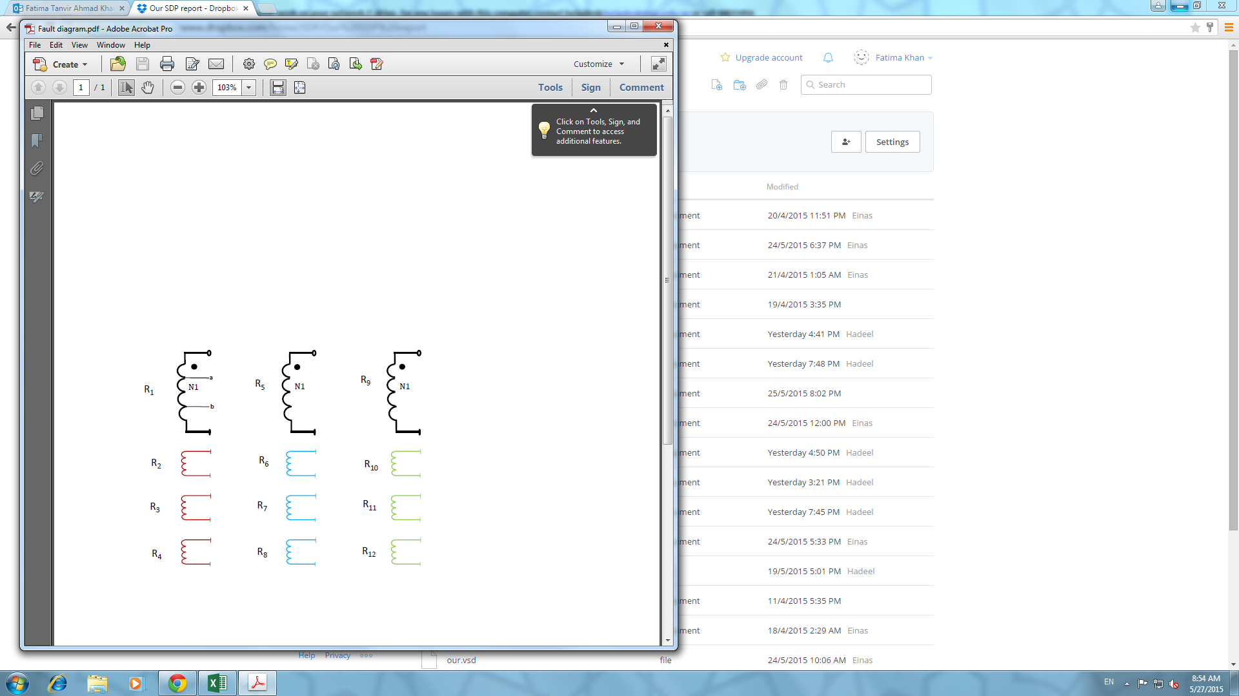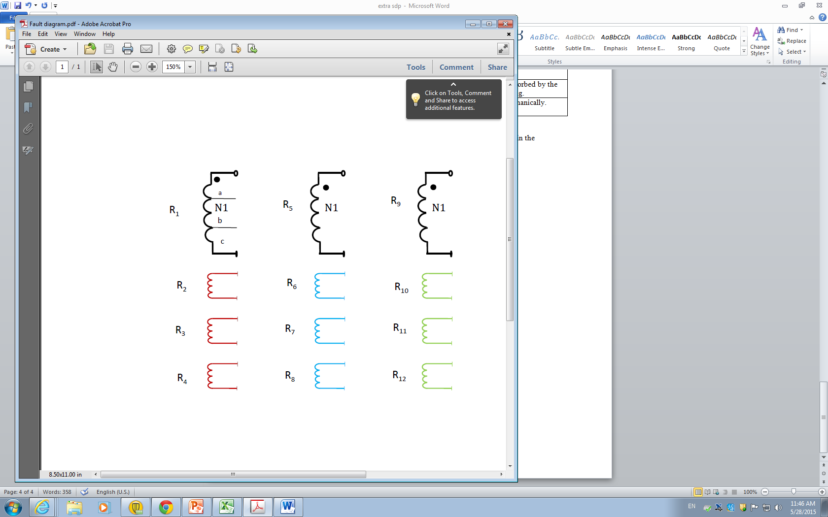

Figure 19: (a) Turn-to-earth fault; (b) Turn-to-turn fault

The [R] and [L] matrices under faulty conditions can be determined using the original matrices and the leakage factors between various coils. In order to find the leakage factor between coils, the geometrical data of the transformer and the position of the fault should be known. The equations shown below were derived in order to find the new elements of these matrices.

Assuming a turn-to-earth fault occurs in coil 1, the coil will be divided into sub coils ‘a’ and ‘b’. Thus the resistance of coil 1 will be divided into Ra and Rb, where  and. The flux passing through each sub coil will be given by and. Thus, the total flux in the coil is given by:

. Since  it can be shown that

|  |  |  |
| --- | --- | --- |
|  |  | (33) |

The leakage factor between any two coils is given by

|  |  |  |
| --- | --- | --- |
|  |  | (32) |

From (31), the inductance of a coil is directly proportional to the square of number of turns in that coil. Therefore,

|  |  |  |
| --- | --- | --- |
|  | Substituting (33) in (32)    Then    Substituting (35) and (33) in (31)    Rearranging (36) and taking all La terms together | (33)  (34)  (35)  (36) |

Similar analysis can be done to obtain the self-inductance of sub coil ‘b’ (Lb) in terms of the known inductance L1 and the leakage factor of coils ‘a’ and ‘b’.

From (32) and (33)

|  |  |  |
| --- | --- | --- |
|  |  | (37) |

Thus,

|  |  |  |
| --- | --- | --- |
|  |  | (38) |

Substituting (38) and (33) in (31)

|  |  |  |
| --- | --- | --- |
|  |  | (39) |

Rearranging (39) and taking all Lb terms together

|  |  |  |
| --- | --- | --- |
|  |  | (40) |

Substituting (36) and (40) in (33), the mutual inductance of the two sub-coils can be expressed as:

 (41)

The new L matrix can now be determined using (36), (40) and (41) after determining the leakage factors between various coils. This work will be carried on in the second part of the project.

# **CHAPTER 5: CONCLUSION AND FUTURE WORK**

## 5.1. Conclusion:

* Alternative solutions have been analyzed for the design of a three-phase to five-phase transformer and a new connection scheme has been proposed.
* The proposed transformer has been designed mechanically and electrically.
* The proposed transformer has been simulated using Simulink and modeled using Finite Element Magnetics Modelling (FEMM).
* The proposed transformer has been modeled using R and L matrices
* Mathematical analysis of a turn-to-earth fault in the primary side of the proposed transformer has been carried out.

## 5.2. Future Work

* Building the hardware of the designed transformer.
* Carrying out the mathematical analysis of a turn-to-earth fault in the secondary side of the proposed transformer.
* Carrying out the mathematical analysis of a turn-to-turn fault in the primary and secondary sides of the proposed transformer.
* Simulating the turn-to-earth and turn-to-turn faults using available softwares.
* Writing a research paper from the findings of the project.

# **References:**

[1] Lebedev, V., "Transformer basics," *Electrical Insulation Conference and Electrical Manufacturing Expo, 2007*, pp.356-359, 22-24 Oct. 2007

[2]Bloomquist, Walter C., "Select the Right Transformer Winding Connection for Industrial Power Systems," *Industry Applications, IEEE Transactions on* , vol.IA-11, no.6, pp.641,645, Nov. 1975

[3] El Hayek, J., "Transformer design as a key for efficiency optimization," *Electrical Machines (ICEM), 2010 XIX International Conference on* , vol., no., pp.1,4, 6-8 Sept. 2010

[4]Dianbo Fu; Lee, F.C.; Shuo Wang, "Investigation on transformer design of high frequency high efficiency dc-dc converters," *Applied Power Electronics Conference and Exposition (APEC), 2010 Twenty-Fifth Annual IEEE* , vol., no., pp.940,947, 21-25 Feb. 2010

[5] Kohan, Navid Abbasi; Abbaszadeh, K., "Influence of nonsinusoidal flux waveform on transformer design methodology," *Power Electronic & Drive Systems & Technologies Conference (PEDSTC), 2010 1st* , vol., no., pp.57,62, 17-18 Feb. 2010

[6] D. Bhalla, R. Bansal and H. Gupta, 'Integrating AI based DGA fault diagnosis using Dempster–Shafer Theory', *International Journal of Electrical Power & Energy Systems*, vol. 48, pp. 31-38, 2013.

[7]V. Sankar, 'Preparation of transformer specifications', IEEE Southern, 2012.

[8] J.E. Parton, A general theory of phase transformation, Proceedings of the IEEE Part IV: Institution Monographs 99 (2) (1952) 12-23.

[9] A.Iqbal, S.Moinuddin, M.Khan, S.M.Ahmed, H.Abu-Rub, A novel three-phase to five-phase transformation using a special transformer connection, IEEE Transactions on Power Delivery 25 (3) (2010) 1637-1444.

[10] S.Moinoddin, A.Iqbal, H.Abu-Rub, M.Khan, Sk.Ahmed, Three-phase to seven-phase power converting transformer, IEEE Transaction on Energy Conversion 27 (3) (2012) 757-766.

[11] A.S.Abdel-Khalik, Z.Shafik, A.Elserougi, S.Ahmed, A.Massoud, A static three-phase to five-phase transformer based on Scott Connection, Elsevier Electric Power Systems Research 110 (2014) 84-93

[12] Bastard, P.; Bertrand, P.; Meunier, M., "A transformer model for winding fault studies," *Power Delivery, IEEE Transactions on*, vol.9, no.2, pp.690,699, Apr 1994

# **Appendix A:**

**Phasor diagram calculations**

* **Output phase 'c'**

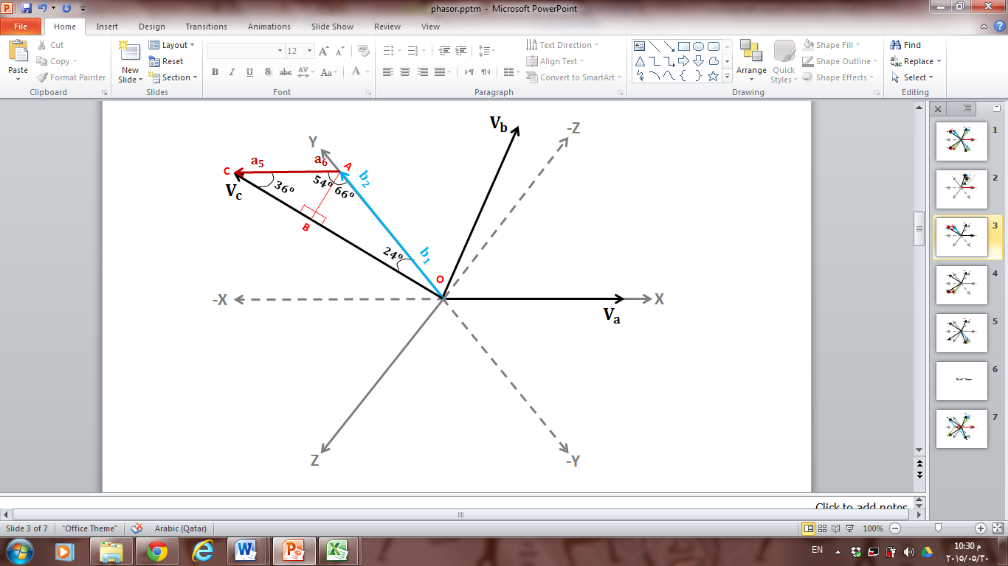

Figure 20:Mathematical Analysis of phase 'c'



* **Output phase 'd'**

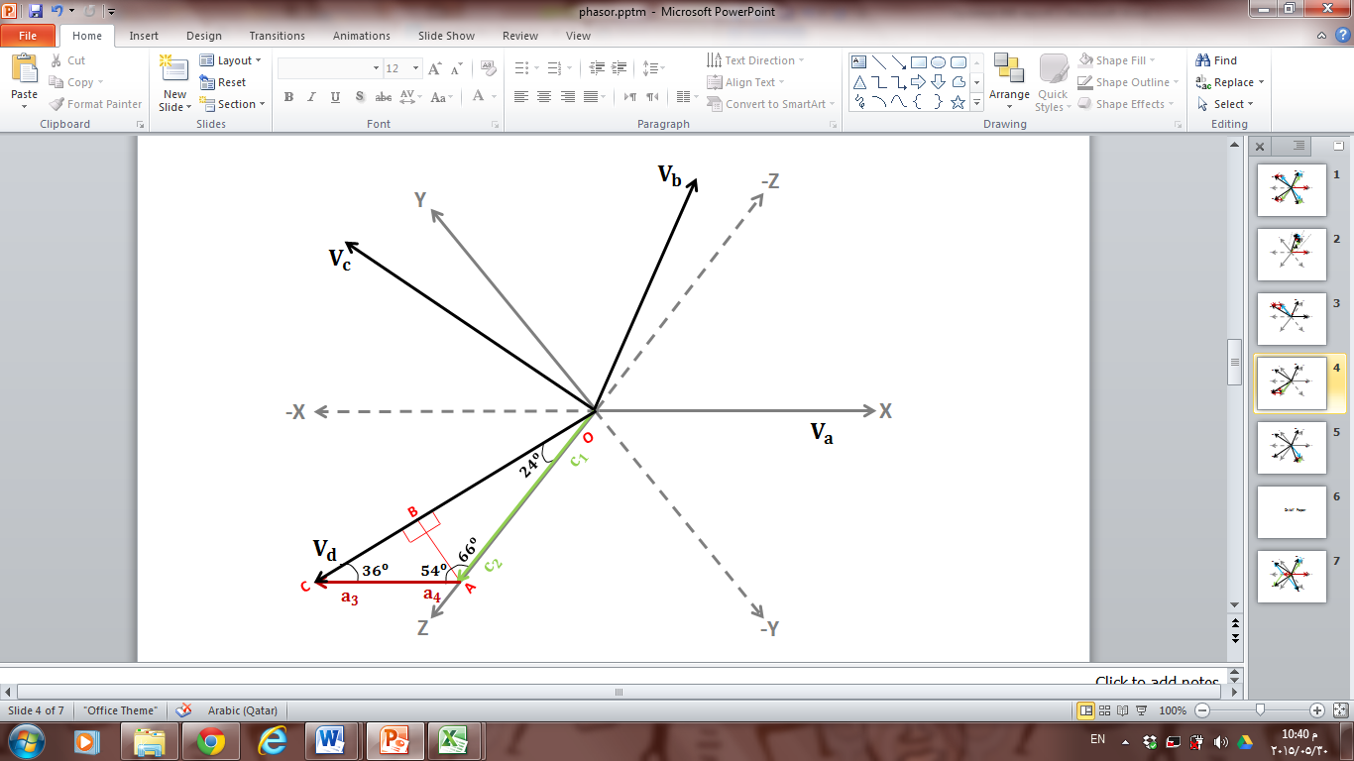

Figure 21:Mathematical Analysis of phase 'd'

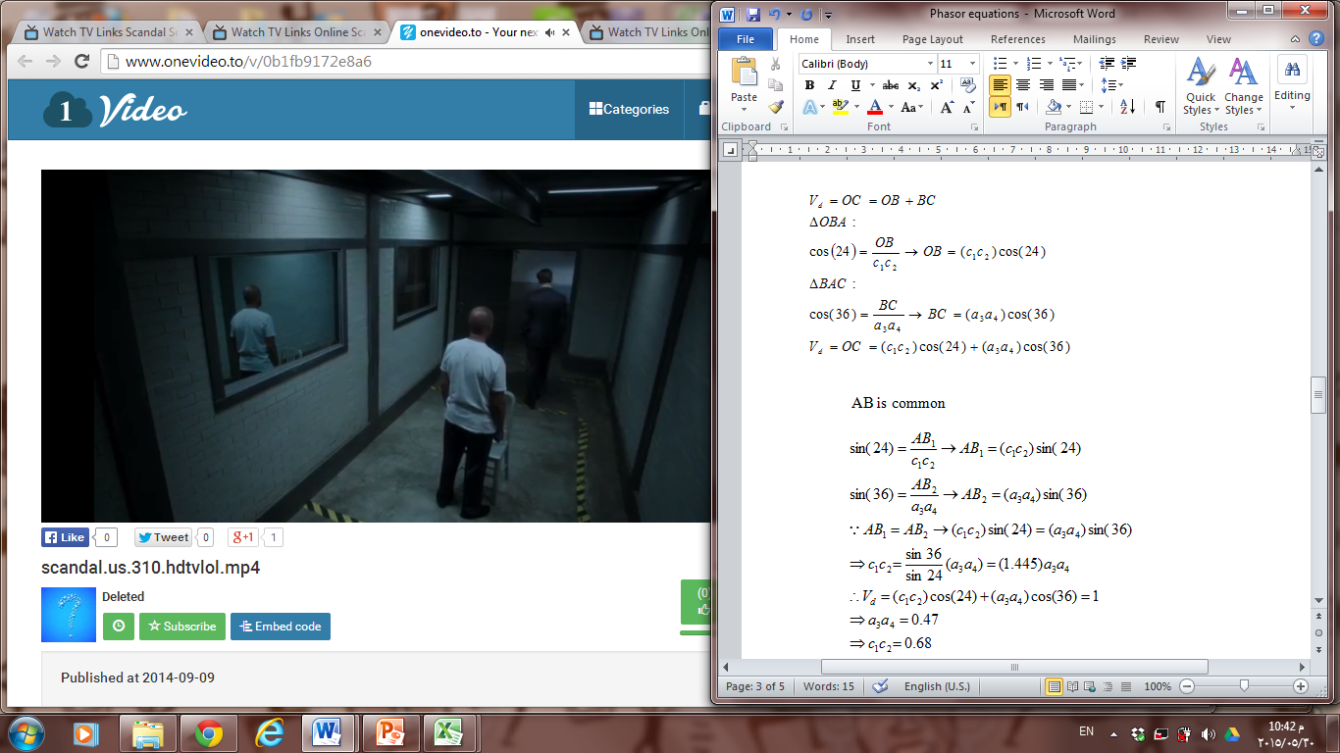

* **Output phase 'e'**

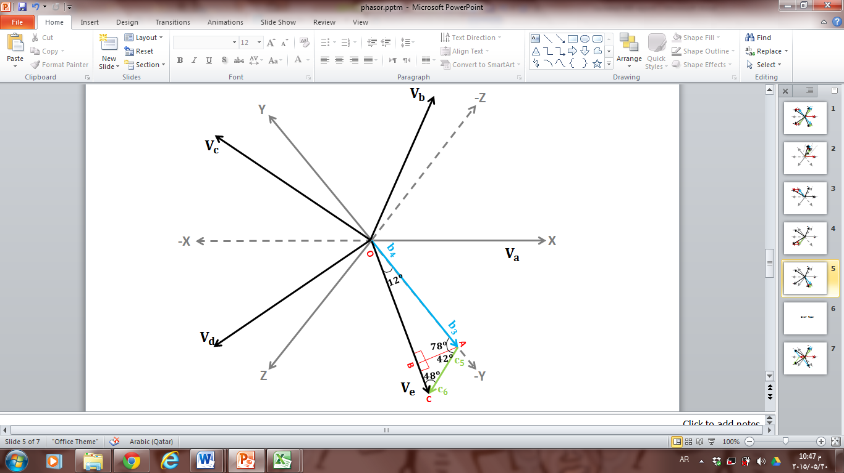

Figure 22: Mathematical Analysis of phase 'e'

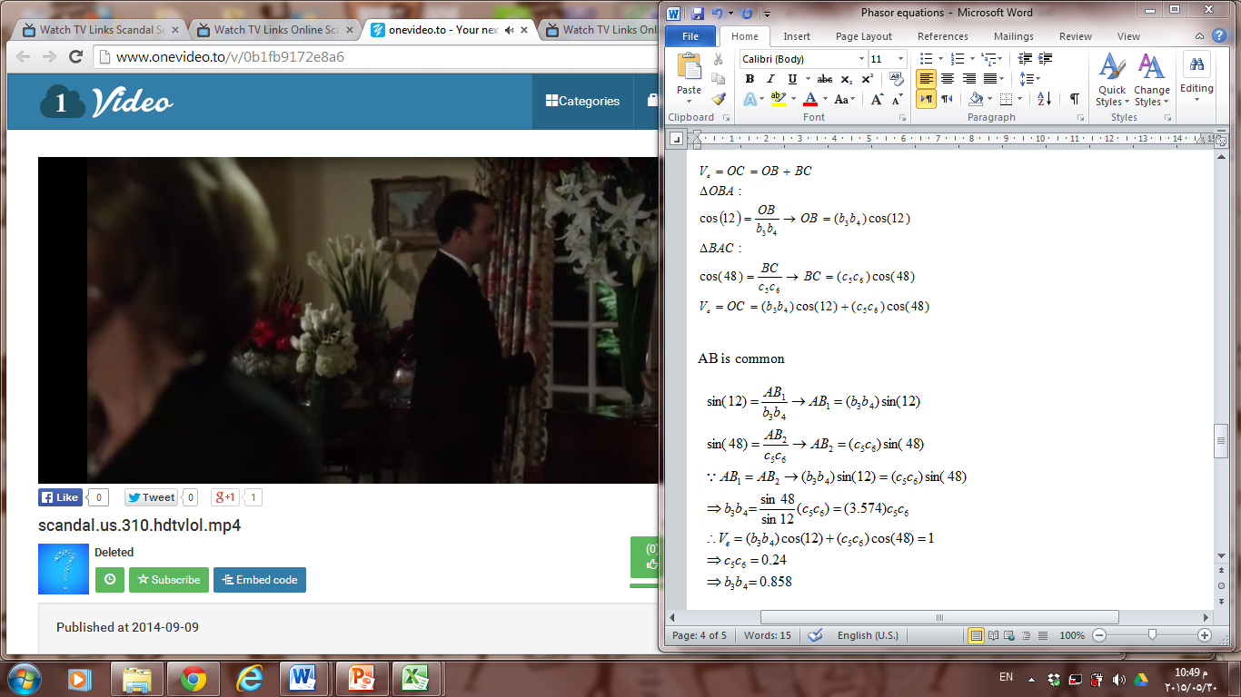 

# **Appendix B:**

**Winding Connection Diagrams of Alternative Designs**

* **Alternative Design 1**

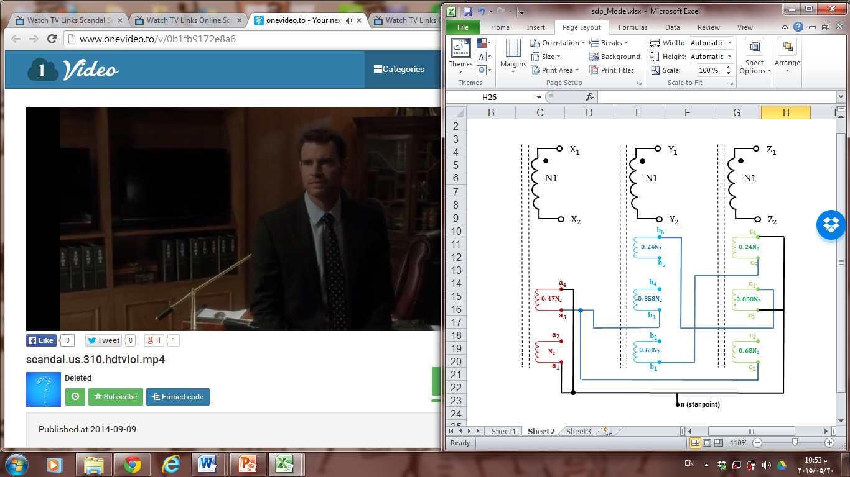

Figure 23: Winding connections of alternative design 1

* **Alternative Design 2**

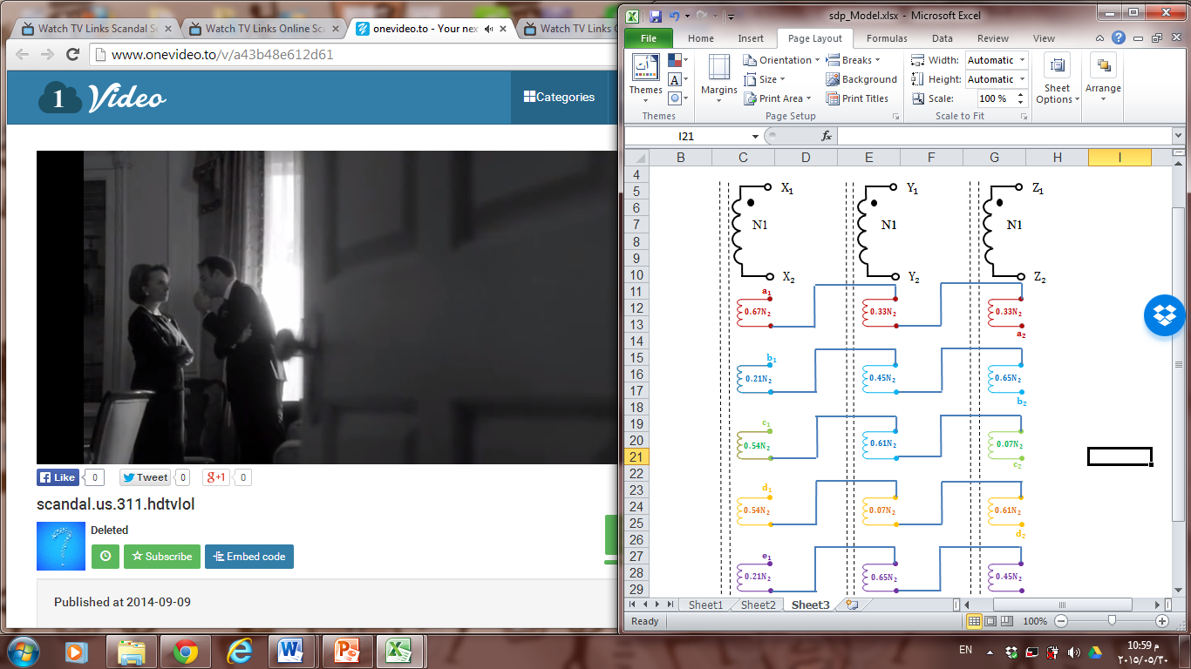

Figure 24: Winding connections of alternative design 2

**Simulations of Alternative Designs**

**Simulation results of the proposed Design:**

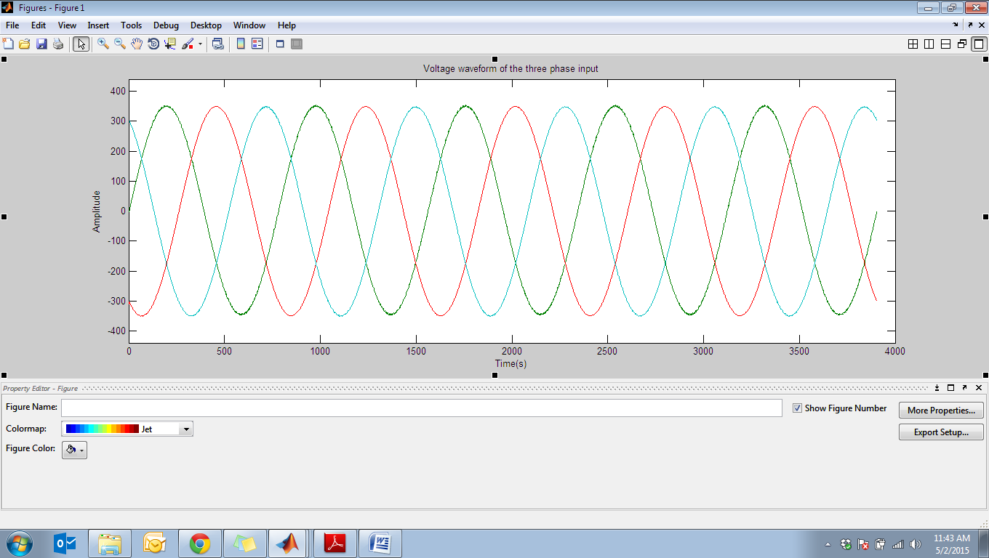

Figure 25: Waveform of the three phase voltage supply

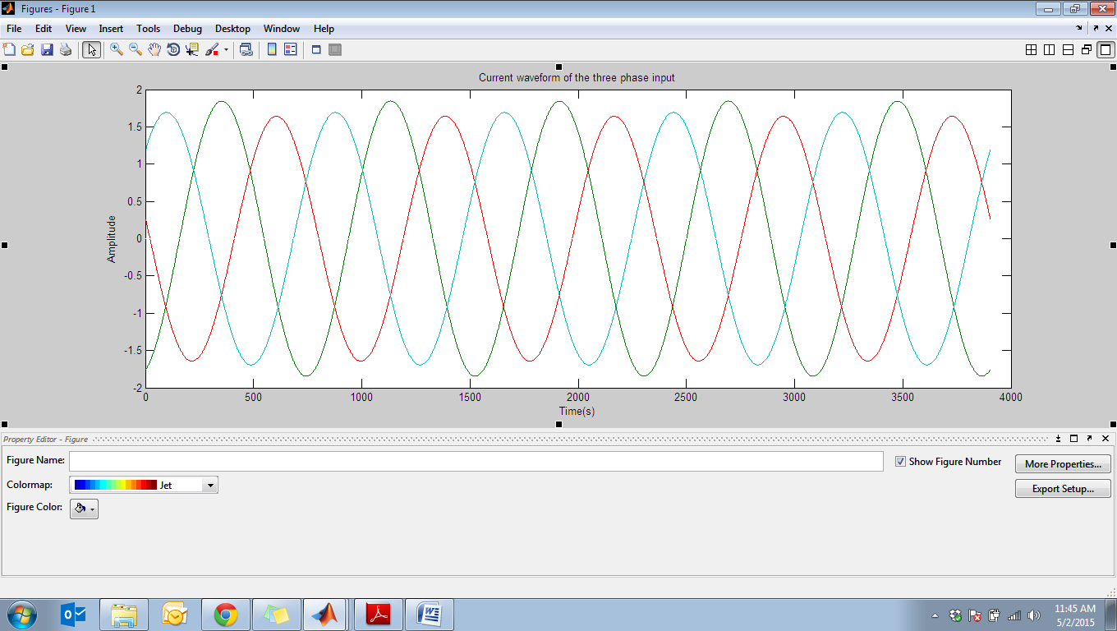

Figure 26: Waveform of the three phase current supply

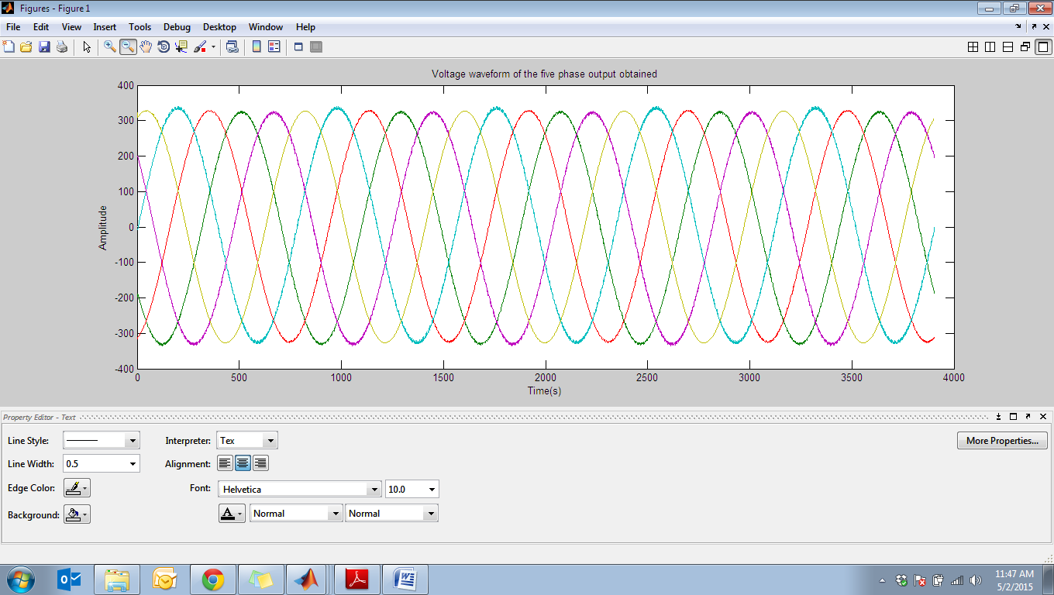

Figure 27: Voltage waveforms obtained at the output

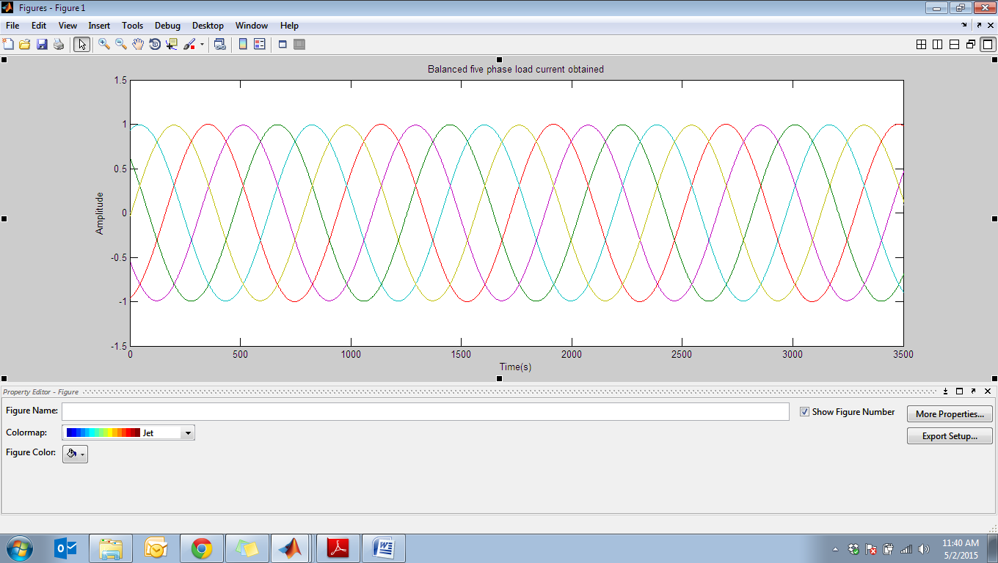

Figure 28: Current waveforms obtained at the output

As shown in the figures above, balanced five phase output voltages and currents were obtained.

**Simulation of Alternative Design 1:**

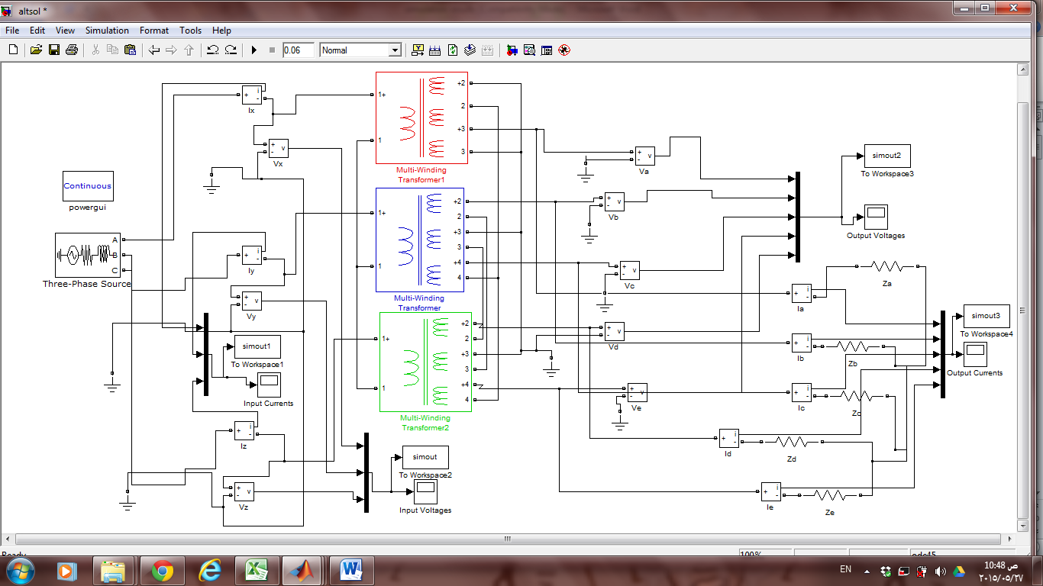

Figure 29: Simulation of Alternative Design 1

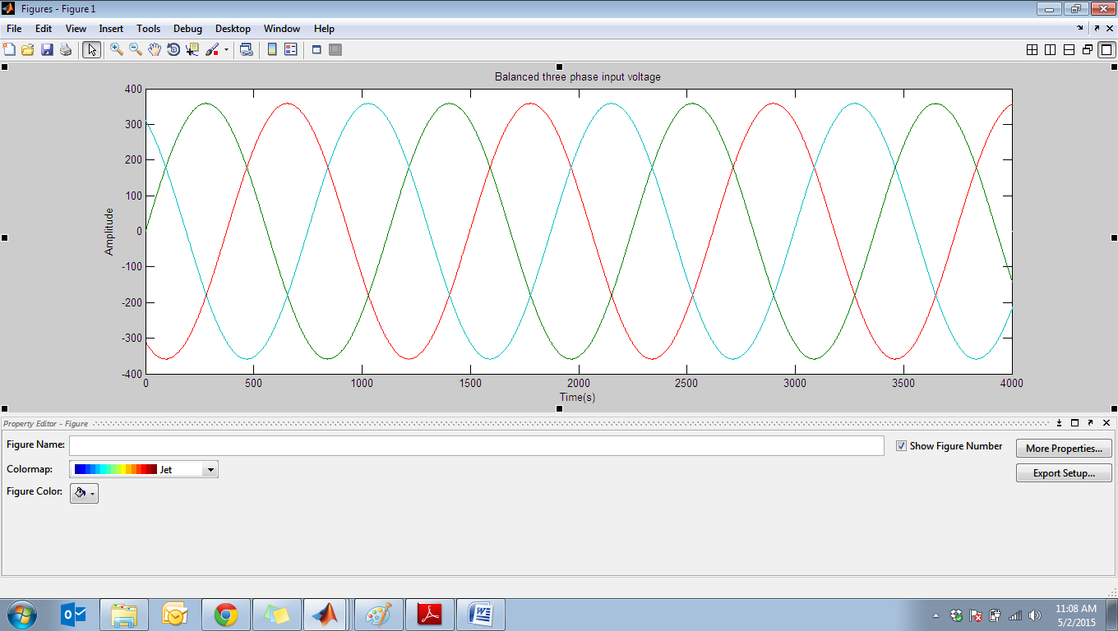

Figure 30: Waveforms of the balanced three phase voltage input supply

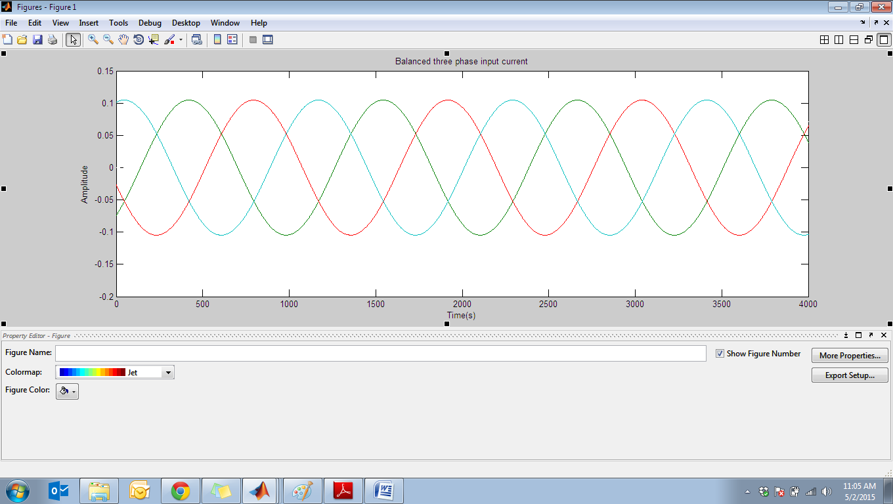

Figure 31: Waveforms of the balanced three phase current input supply

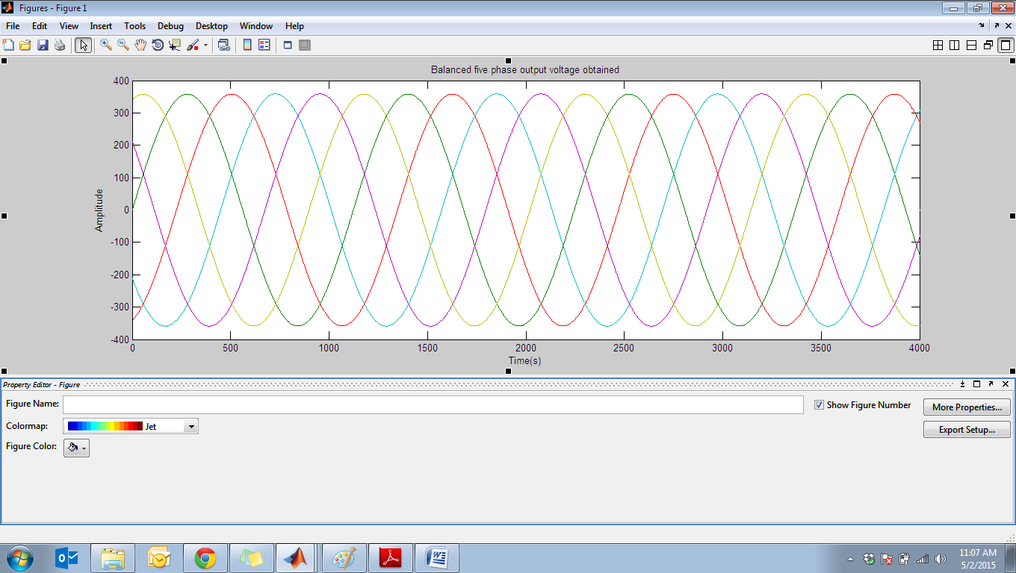

Figure 32: Waveforms of the balanced five phase voltage output obtained



Figure 33: Waveforms of the balanced five phase current output obtained

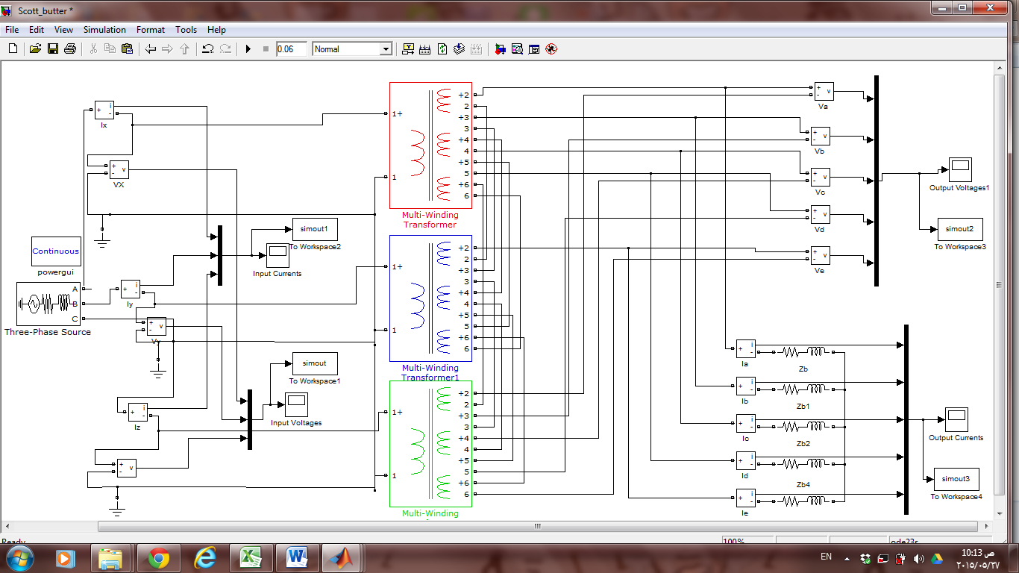Simulation of Alternative Design 2:

Figure 34: Simulation of Alternative Design 2

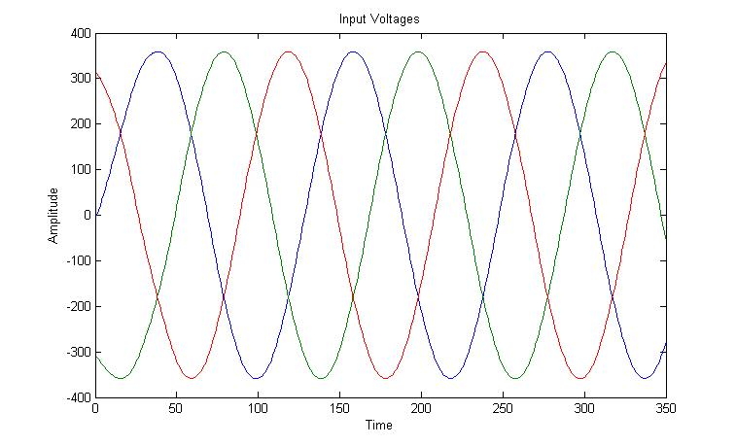

Figure 35: Waveforms of the balanced three phase voltage input supply

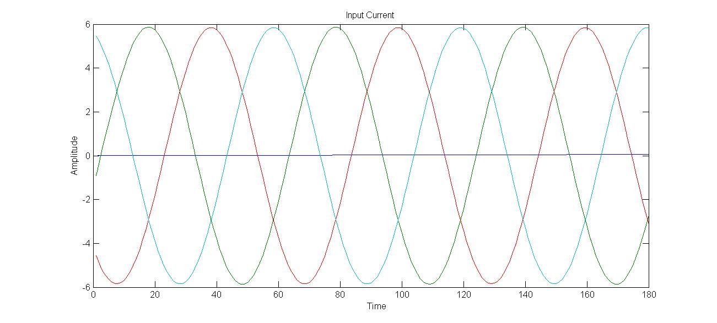

Figure 36: Waveforms of the balanced three phase current input supply

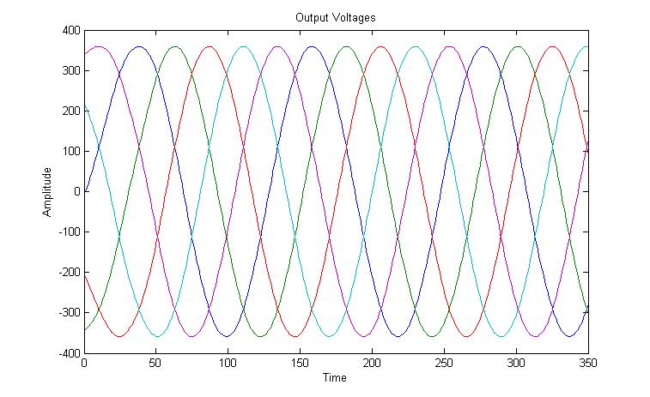

Figure 37: Waveforms of the balanced five phase voltage output obtained

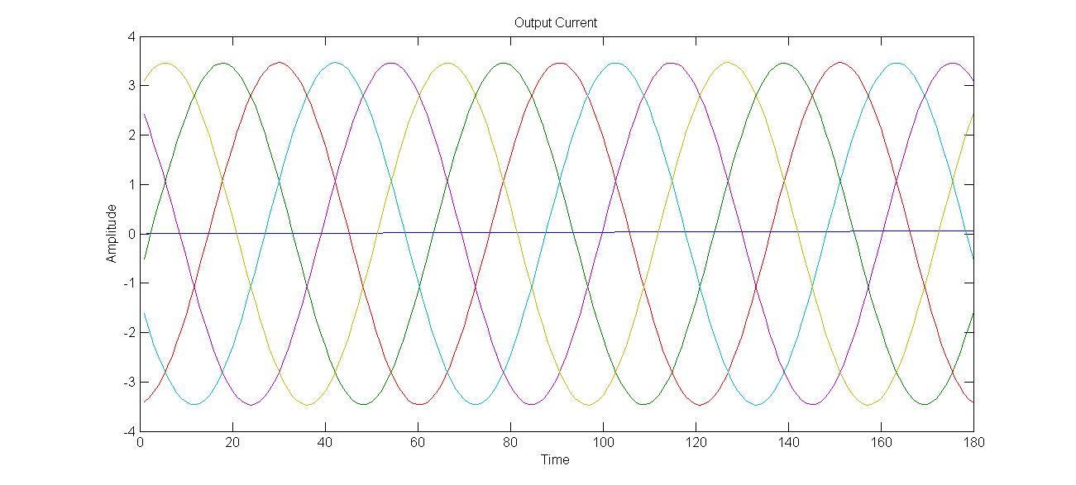

Figure 38: Waveforms of the balanced five phase current output obtained